

**Network Security**

Year 2/3 (2025/26), Semester 3/5

**SCHOOL OF INFOCOMM TECHNOLOGY**

Diploma in Cybersecurity & Digital Forensics

**ASSIGNMENT**

**Duration:**  Weeks 5 -17

**Weightage:**   40%

**Tutorial Group: __T02___ Team Number: _______** **Team Grade: _______**

|  |  |  |
| --- | --- | --- |
| **Student Name** | **Student Number** | **Combined Grade** |
| 1. Shavelin | S10259194D |  |
| 1. Cloe | S10268378D |  |
| 1. Phyllis | S10266721B |  |
| 1. Jaya | S10268205E |  |

**Table of Contents**

1. Business Requirement & Firewall Comparison 4

1.1 Evaluation Criteria 5

1.2 Firewall Research & Comparison 5

1.3 Firewall comparison table 8

2. Network Design & Architecture 9

2.1. Network Overview 9

2.2. Diagram & IP/Zoning Plan 9

3. Firewall Configuration 9

3.1. Singapore Office 9

3.2. Kuala Lumpur Office 14

3.3. VPN Setup 23

1. Create an Internet Key Exchange Profile 23

2. Create an IPSec Crypto Profile 23

3. Create IKE Gateway 23

4. Create Tunnel Interface 23

5. Create IPSec Tunnel 23

6. Create Security Policies 23

7. Add Static Routes 23

8. Commit Configuration 24

How to check if VPN is being set up? 24

4. Testing & Results 24

KL Test Results: 24

5. Conclusions & Recommendations 25

6. Appendix 25

6.1. Member Contributions 25

6.2. Additional Screenshots / References 26

# **Business Requirement & Firewall Comparison**

## **1.1 Evaluation Criteria**

There are various factors to consider when choosing an appropriate Next Generation Firewall. Some of our considerations include Data protection, Network Segmentation, Application Visibility and Control and lastly, Remote access and VPN connectivity.

**Data Protection:** To protect sensitive business and customer data from various malware and external attacks. With this considerations, the NGFW must offer features such as Intrusion Prevention Systems (IPS), antivirus scanning, and threat intelligence like cloud-based updates.

**Network Segmentation:** To be able to divide the larger network into smaller segments for the SG and KL branches and their separate departments (HR, IT, etc.) using features such as Virtual LANs, Application and User control like application filters/groups and Advanced Threat Protection capabilities through segmentation.

**Application Visibility and Control:** To manage user access to cloud apps and social media and classify the traffic based of the application identity. Some features that the NGFW should have include, Identifying users based on User-ID, Include Policy-Based Control and Provide dashboards like Application Command Centre (ACC).

**Remote access and VPN connectivity:** To extend corporate network through SG and KL by providing encrypted connections over the internet connection, allowing everyone working remotely to still be securely logged on to the company’s network. NGFW should have IPSec/SSL VPN tunnels, Secure client access and lastly Device and User Authentication.

These are the following leading firewall solutions based on their reputation, capabilities and relevance to the company’s needs:

* Palo Alto Networks PA-Series
* FortiGate (Fortinet)
* Cisco FirePOWER Series
* Sophos Firewall (XGS Series)

## **1.2 Firewall Research & Comparison**

1. **Palo Alto Networks PA Series**

It is a machine learning-powered Next Gen Firewall (NGFW). It is a network appliance that processes all traffic coming into the network and going out as well. One of its interesting features is its ability to analyse encrypted traffic, which is crucial for our company's security needs.

Furthermore, its flexibility in admin options is very impressive, which would allow our individual departments to tailor the network settings to their specific requirements.

Some of its key features include:

* **Advanced Threat Detection:** Palo Alto's machine learning capabilities allows it to block both known and unknown threats. Due to its frequent updates in threat signatures via cloud intelligence, This aligns with our company’s Data protection requirements by ensuring we will not be vulnerable to evolving threats.
* **Encrypted Traffic Analysis:** The firewall's decryption of SSL/TLS traffic allows complete inspection of encrypted traffic. This ensures visibility into hidden traffic, preventing malicious content from infiltrating the network and bypassing the firewall, meeting our standards for Data Protection
* **Quality of Service (QoS) Management:** The QoS feature enables prioritisation of network traffic during peak periods which ensures optimal performance for critical applications and services. Combined with App-ID, which identifies traffic based on applications rather than ports, giving us precise control over who can access what, meeting our standards for Application Visibility and Control and Network Segmentation.
* **Secure Remote Access and VPN:** Palo Alto's GlobalProtect provides secure and seamless remote access to our network, enabling our remote employees to connect to our internal resources regardless of their location, while maintaining the highest levels of security and compliance. It ensures all devices comply with our security policies before granting access, which is especially important for our employees from SG and KL, who need to be able to work together seamlessly while also ensuring our data is protected.

Given these features, Palo Alto meets all our company’s business requirements. Its flexibility, granular control, advanced threat detection capabilities, and consistent remote access features make it an excellent fit for our large organisation in SG and KL.

1. **Forinet FortiGate**

FortiGate NGFW accelerates security and networking performance to manage today’s data-rich traffic and cloud-based applications. It is backed up by FortiGuard AI-Powered Security Services offer real-time protection and responses against even the most unique threats. Furthermore, Its single operating system simplifies management by consolidating security policies across the network.

Some of its key features include:

* **Advanced Threat Protection:** FortiGate comes with strong security tools like Intrusion Prevention Systems (IPS), antivirus scanning, and sandboxing (FortiSandbox). With real-time updates from FortiGuard, it helps detect and stop new types of threats. This supports our goal of data protection.
* **Network Segmentation and Policy Control:** FortiGate supports VLANs, virtual domains (VDOMs), and zone-based segmentation. This allows departments like HR, IT, and Sales in both our SG and KL offices to be separated, supporting Network Segmentation. However, it does not have features like App-ID and User-ID-based control, which makes it difficult to integrate rules for specific departments.
* **Application Control:** It supports deep packet inspection (DPI) and has a built-in list of thousands of applications it can recognise and control. However, it doesn’t offer the same detailed visibility or dashboard tools that Palo Alto provides (like App-ID and ACC), which makes it harder to view usage and apply very specific app-based policies
* **VPN and Remote Access:** FortiGate supports both IPSec and SSL VPN, and can work with FortiClient to allow secure access for remote users. This is good for our SG and KL offices, especially with more people working remotely. But, it doesn’t have as advanced checks for devices or seamless integration as Palo Alto’s GlobalProtect.

Considering all these factors, While Fortinet ForrtiGate is a high-performance and cost-effective NGFW which offers excellent data protection, reliable network segmentation and effective VPN support, it does not provide granular application and user-level control which is essential for our company’s specific departments. It also lacks seamless remote access experience compared to Palo Alto’s GlobalProtect. Therefore, FortiGate is a strong option but not the best fit for company.

1. **Cisco FirePOWER Series**

Cisco Firepower is Cisco’s next-gen firewall solution that combines the older ASA firewall with newer threat protection features from Sourcefire. It is suitable for larger companies and supports features like IPS, malware protection, and VPN connectivity.

Some of its key features include:

**Advanced Threat Protection:** Firepower uses Cisco’s IPS and AMP (Advanced Malware Protection) to detect threats and malware in real-time. This meets our company’s Data Protection needs by helping to block advanced attacks like ransomware or zero-days.

**Application Visibility & Control:** It supports thousands of apps and URL categories, allowing basic traffic control. However, it lacks the more detailed controls and visual dashboards which affects Application Visibility and Control.

**Encrypted Traffic Inspection:** Firepower can decrypt and inspect HTTPS traffic to check for hidden threats, helping with Data Protection, though setup is more intricate.

**VPN & Remote Access:** Supports both IPSec and SSL VPN with Cisco AnyConnect. This allows secure access for staff working remotely from SG and KL, fulfilling **Remote Access and VPN** needs.

**Centralized Management:** Uses Firepower Management Centre (FMC) for monitoring and managing policies. It works well for large deployments, but might be harder to work with for users new to Cisco tools.

Cisco Firepower is reliable for core protection and remote access, but fails to fulfil things such as user tracking and app-level control. It meets most of our requirements but lacks the flexibility and ease-of-use that Palo Alto offers for more detailed policies. While it’s strong in core security and remote access, it’s not as flexible or easy to manage when it comes to user-level controls or detailed application visibility compared to Palo Alto.

1. **Sophos XG Series**

Sophos XG is a NGFW that focuses on simplicity, speed, and a tight connection with endpoint devices. It’s a good option for small to mid-sized businesses that want strong protection without complex setup. While it covers the basics well, it’s not as advanced in terms of detailed traffic control and user-based policies.

Some of its key features include:

**Advanced Threat Protection:** Uses deep packet inspection (DPI), IPS, and antivirus to block malware and attacks. It also connects to SophosLabs for real-time threat intelligence. This supports our Data Protection needs effectively.

**Synchronised Security & User Awareness:** Through a feature called Security Heartbeat, it connects directly with Sophos endpoints to isolate infected devices. This helps with Network Segmentation but relies on using other Sophos products for best results.

**Application & Web Control:** Supports app and web filtering, including control over cloud and social media apps. However, it doesn’t offer the same level of granularity or dashboards like Palo Alto’s App-ID and ACC, so Application Visibility and Control is more limited.

**VPN & Remote Access:** Offers IPSec and SSL VPN and centralised management via Sophos Central, supporting our need for Remote Access.

Sophos XGS is easy to deploy and manage, especially for teams with less firewall experience. It performs well in basic security and remote access but lacks the deeper control and integration our company would want for enforcing specific department policies. For our setup, Palo Alto remains the stronger choice.

## **1.3 Firewall comparison table**

|  |  |  |  |  |
| --- | --- | --- | --- | --- |
| **Business Requirement** | **Palo Alto PA-Series** | **Fortinet FortiGate** | **Cisco Firepower** | **Sophos XG Series** |
| **Data Protection** | Strong ML-based IPS, threat intel & sandboxing | Good IPS, antivirus & FortiSandbox | IPS & AMP with good detection | DPI, antivirus, real-time threat intel |
| **Network Segmentation** | App-ID & User-ID for granular control | VLANs & zones, lacks user-level rules | Basic segmentation, lacks App-ID | Security Heartbeat (requires endpoints) |
| **Application Visibility & Control** | App-ID, ACC dashboard, detailed policies | DPI & app control, lacks fine granularity | URL/app control, limited dashboards | Basic app/web filtering, limited visibility |
| **Remote Access & VPN Connectivity** | GlobalProtect with posture checks & device control | IPSec/SSL VPN, FortiClient, less seamless | Cisco AnyConnect, secure but complex | IPSec/SSL VPN, lacks posture checks |
| **Ease of Use & Management** | Intuitive UI, strong admin flexibility | Simple OS, but limited dashboard features | Complex for new users | Easy to manage, simple for small teams |
| **Overall Fit for Our Company** | Fully meets all requirements | Lacks granular control, less seamless VPN, does not meet the requirements | Limited app/user control, harder to manage, does not meet requirements | Basic control, not ideal for larger orgs, does not meet requirements |

After Analysing through all these firewalls, the NGFW most suited for our company would be Palo Alto Series, it fulfils all the business requirements and more making it a suitable NGFW.

# **Network Design & Architecture**

## **2.1. Network Overview**

## **2.2. Diagram & IP/Zoning Plan**

# **Firewall Configuration**

## **3.1. Singapore Office**

**Virtual network adapters**

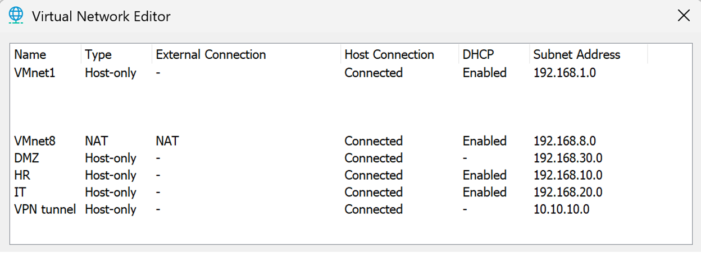

**Firewall interfaces**

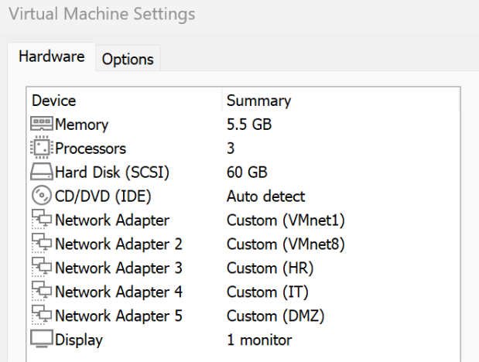

**Security Zones Configuration**

Network > Zones

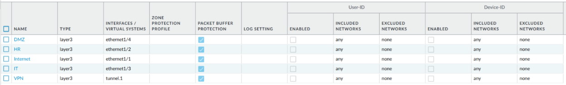

Zones configured to enforce security boundaries between different network segments (DMZ, HR, Internet, IT, VPN). Each interface is assigned to a zone where security policies are applied based on interzone traffic, ensuring that only authorised communication is allowed. Using zone-based architecture provides granular control and reduces risk of lateral movement between departments. It also simplifies policy management by grouping interfaces logically based on trust levels.

**Interfaces Configuration**

|  |  |  |
| --- | --- | --- |
| **Interface** | **IP Address** | **Zone** |
| Ethernet 1/1 | 192.168.8.254/24 | Internet |
| Ethernet 1/2 | 192.168.10.254/24 | HR |
| Ethernet 1/3 | 192.168.20.254/24 | IT |
| Ethernet 1/4 | 192.168.30.254/24 | DMZ |
| Tunnel.1 | 10.10.10.1/30 | VPN |

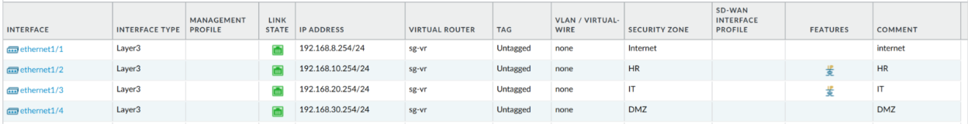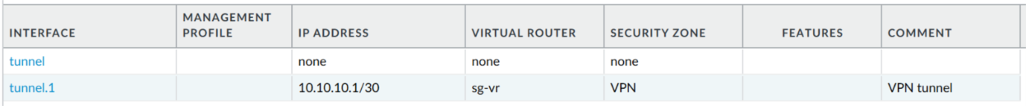

To segment the network by department and purpose, each virtual interface is assigned a specific IP and subnet. Each interface is configured in Layer3 mode with a static IP address and assigned to a security zone. This enables proper routing and policy enforcement between internal zones and external traffic. Segmenting interfaces into dedicated subnets supports isolation.

**Router Configuration**

* Router name: sg-vr

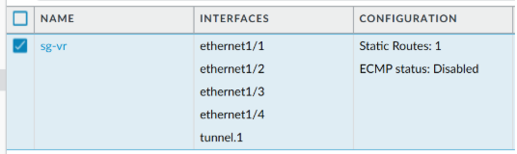

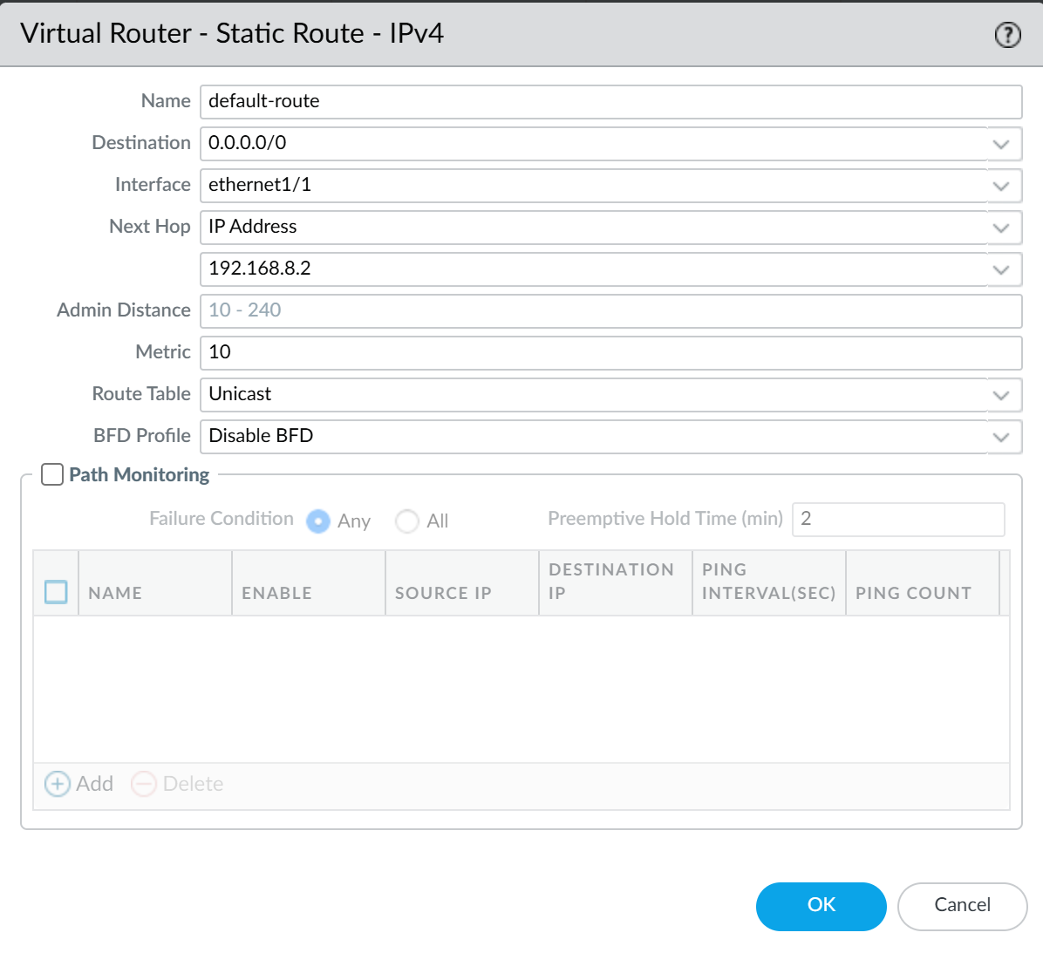

The virtual router is configured with a default route, 0.0.0.0/0, that forwards all Internet-bound traffic to the next hop IP address: 192.168.8.2, via interface ethernet 1/1, which is connected to the VMware NAT network. This route ensures that any traffic not destined for internal networks is directed to the Internet. This is essential for enabling outbound connectivity and ensuring NAT works as expected. Without this configuration, internal hosts would not be able to reach external IP addresses. The static route allows the firewall to function as the central router for all internal zones.

**DHCP Server configuration**

* Ethernet 1/3 (IT)
* Ethernet 1/2 (HR)

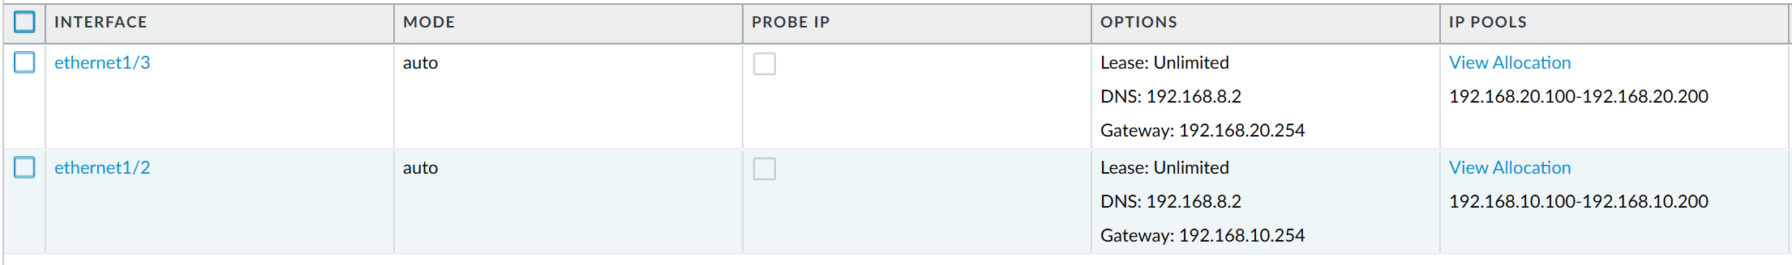

The DHCP server is configured to dynamically assign of IP addresses to client devices. It is configured for the HR and IT departments, allocating IP addresses in the range 192.168.10.100-192.168.10.200 and 192.168.20.100-192.168.20.200. This allows devices in the respective zones to automatically receive IP configurations without manual setup. To ensure that the firewall’s DHCP range does not overlap with static IP addresses such as the gateway and DNS, this configuration is essential for environments with dynamic clients and helps automate IP management.

**Security Policies**

Security Policies are configured to control interzone traffic and enforce strict access control between the network segments. This setup aligns with the principle of least privilege where only necessary traffic is explicitly allowed; otherwise, by default, interzone traffic is denied. Policies are applied top-down, and traffic is evaluated based on zone, source/destination IP address, application ID, and service. This approach ensures secure communication boundaries.

**Ensure users in HR and IT have traffic allowed to support essential business functions:**

* Web and DNS traffic
  + Policy name: allow-internal-outbound-web-dns
* Email Traffic
  + Policy name: allow-internal-outbound-email
* Remote Access
  + Policy name: allow-internal-outbound-remote-access

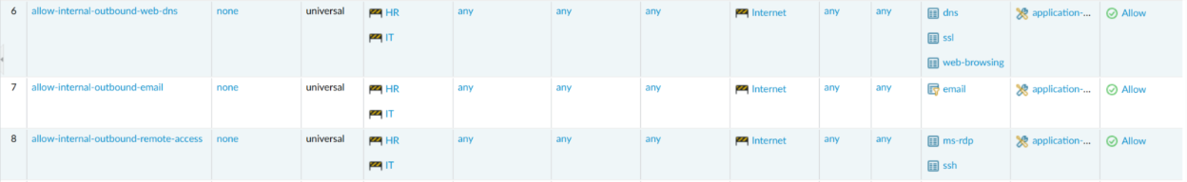

* Application filter “email” used for email traffic
* 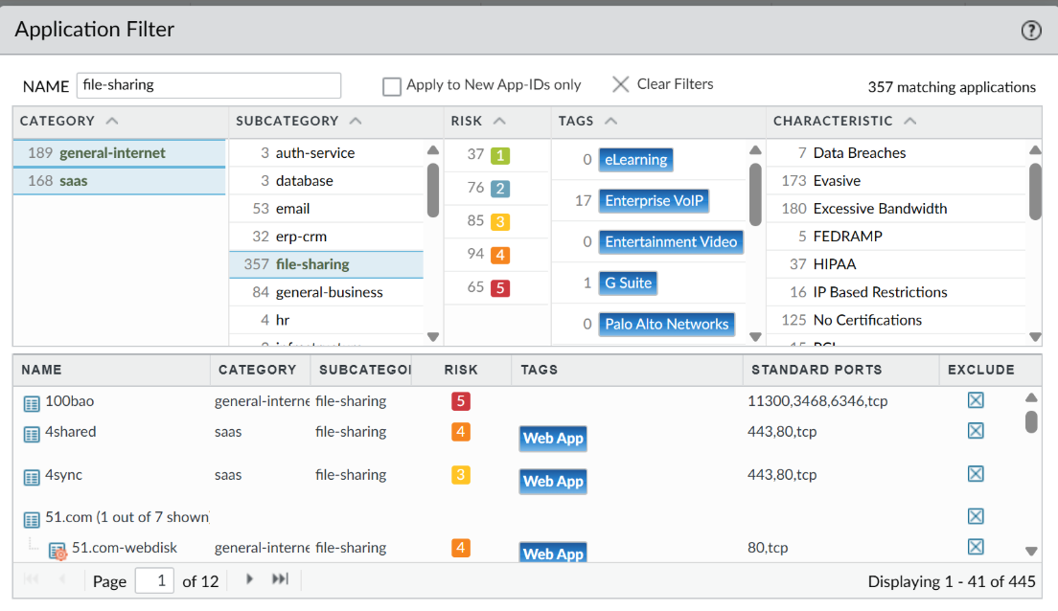

**Enable standard network applications**

* Policy name: allow-business-apps
* Applications deemed essential by our team:
  + Adobe creative cloud
  + Gmail
  + Google
  + Zoom
  + essential office programs (application filter)
* 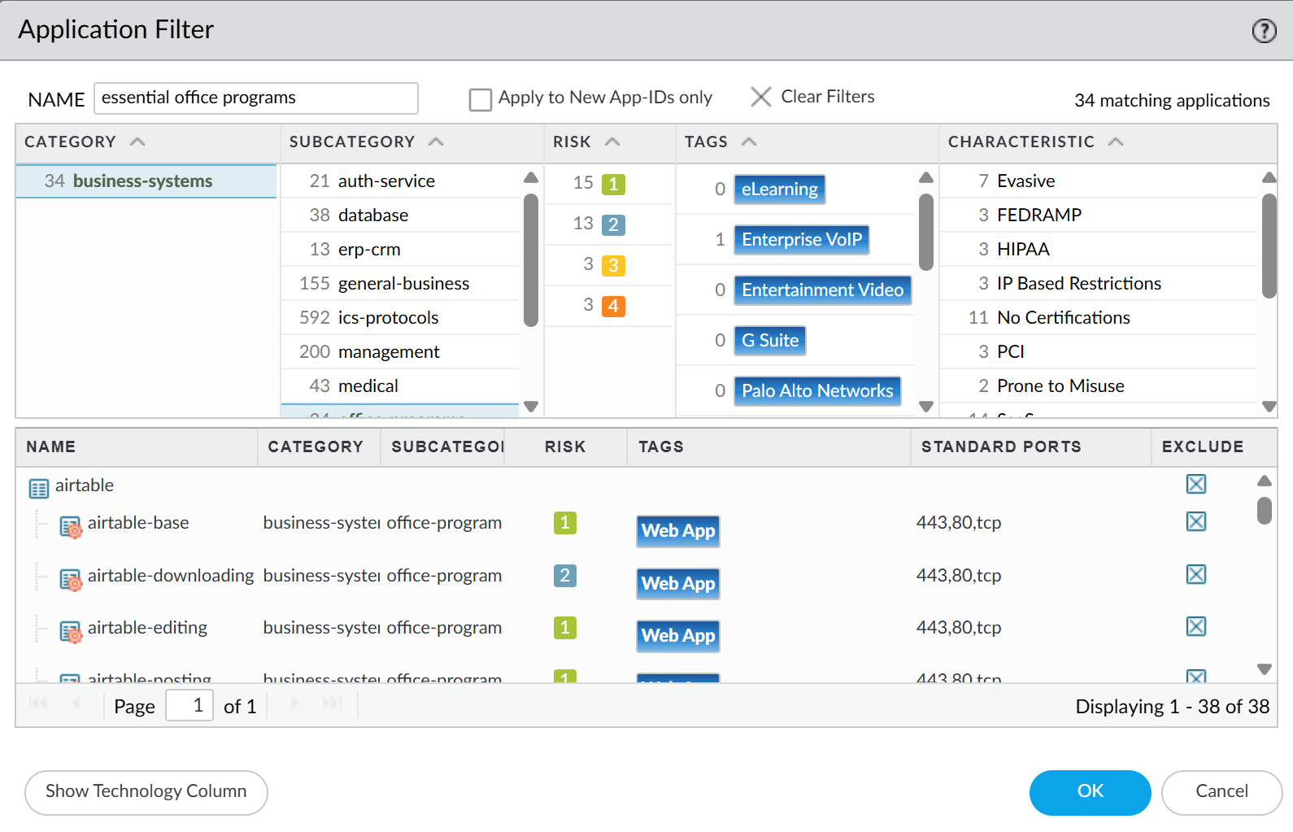
* 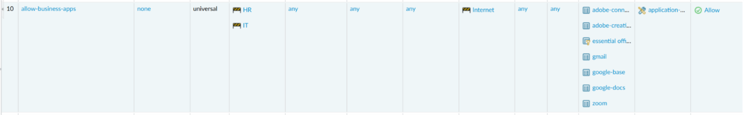

**Users in HR department can access LinkedIn and Facebook:**

* Policy name: allow-hr-linkedin-facebook-base
* 

**Users in HR department cannot access LinkedIn Messaging:**

* Policy name: deny-hr-linkedin-messaging
* 

**Users in HR department cannot perform Facebook chat:**

* Policy name: deny-hr-facebook-chat
* 
* URL Category: facebook-chat-block
* 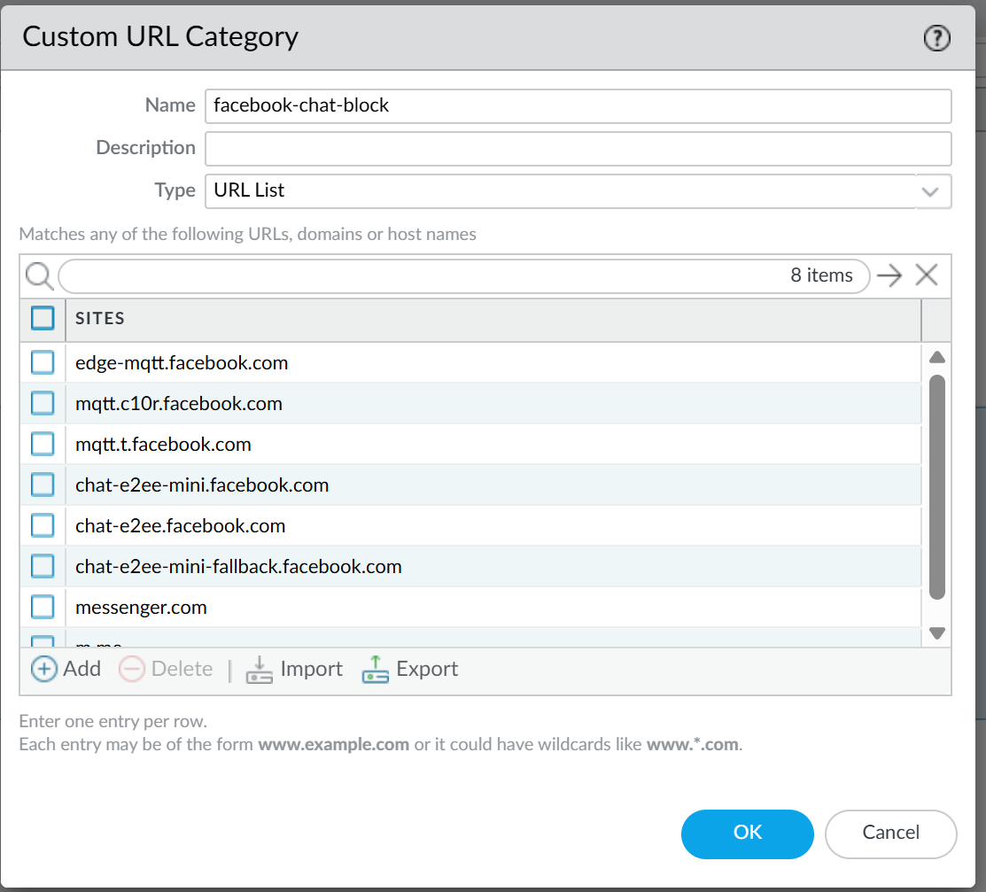

**Users in IT cannot access Facebook and LinkedIn at all:**

* Policy name: deny-it-linkedin-facebook
* 

**Users in HR cannot access online storage services:**

* Policy name: deny-hr-online-storage-services
* file-sharing (application filter)
* 
* 

**NAT Policy**

* Policy name: internet-outbound-NAT

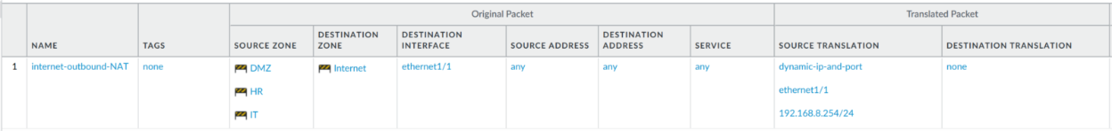

The NAT Policy is configured to allow internal hosts from IT, HR and DMZ zones to access the Internet using the firewall’s public-facing IP address, 192.168.8.254. The NAT rule applies to outbound traffic passing through interface: ethernet 1/1, ensuring that private addresses are translated into a routable IP address. This allows multiple internal hosts to share a single IP using port translation.

**Decryption Policies**

* Banking websites traffic not decrypted
  + Policy name: banking-no-decrypt
  + URL Category: banking-exclude
    - 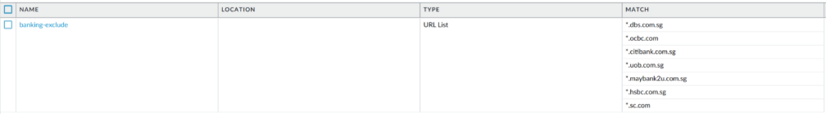
* All other network traffic to be decrypted
  + Policy name: decrypt-all

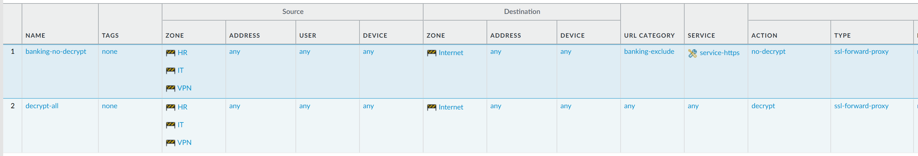

Certificates:

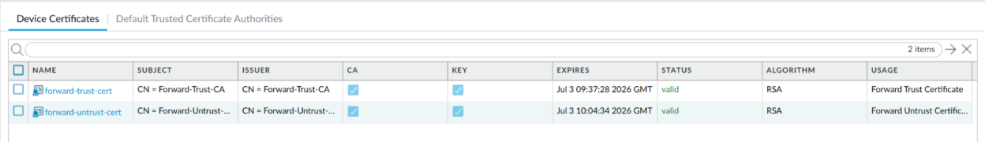

Decryption policies are configured to allow the firewall to inspect encrypted SSL/TLS traffic. In this case decrypt-all enables SSL decryption for all outbound traffic from internal zones, allowing the firewall to inspect HTTPS traffic for threats and to enforce security profiles. The banking-no-decrypt policy excludes sensitive categories like financial services from decryption to maintain confidentiality. The forward-trust-cert is used to re-sign decrypted traffic, preventing browser warnings, while the forward-untrust-cert is applied to untrusted or invalid SSL sessions to block access and alert users. This setup ensures secure, ethical inspection of encrypted traffic and supports data protection requirements.

## **3.2. Kuala Lumpur Office**

**Configuration Steps:**

1. Change settings:

Ensure accurate logging between offices

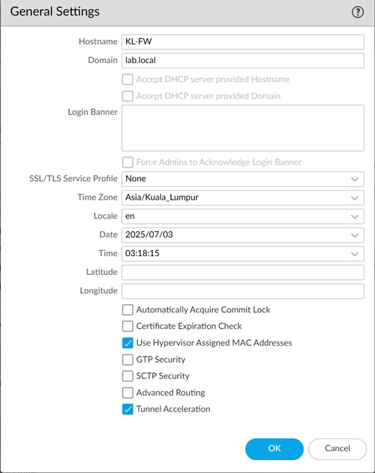

The firewall name was changed to KL-FW and the time zone was configured to Asia/Kuala_Lumpur. Doing this ensures that the logging, threat alerts and scheduled task time stamps are accurate across both offices which could be important for incident response and forensic analysis.

1. Configure interfaces

Segment internal network traffic and apply access control between zones.

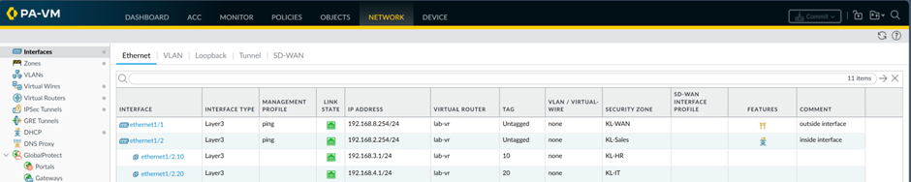

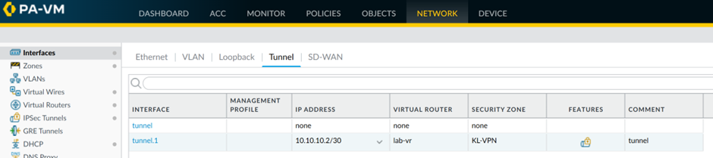



Interfaces and their assigned zones:

Ethernet1/1 – Zone: Sales (trusted)

Ethernet1/2 – Zone: WAN (untrust)

VPN created for secure site-to-site traffic

By making zones the network is segmented which helps restrict lateral movement of threats and allow for granular policy enforcement.

1. Virtual Router

Enable inter-zone routing and define next hops

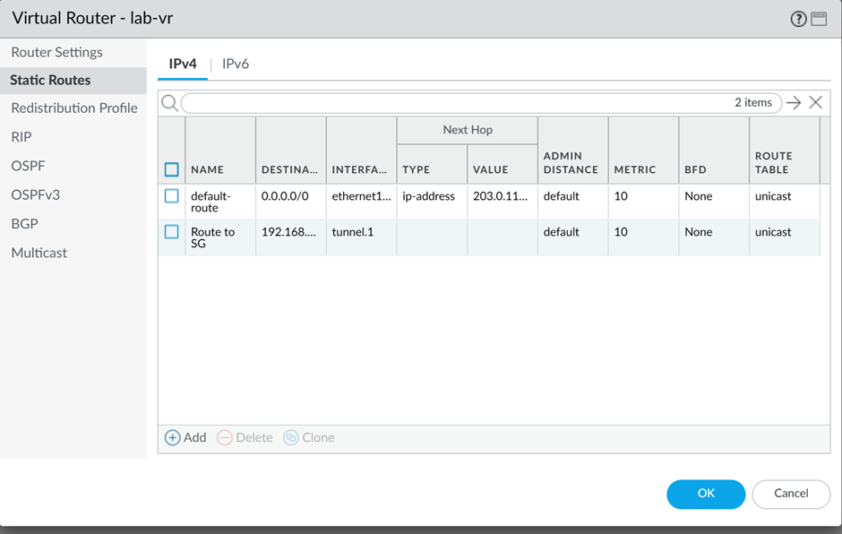

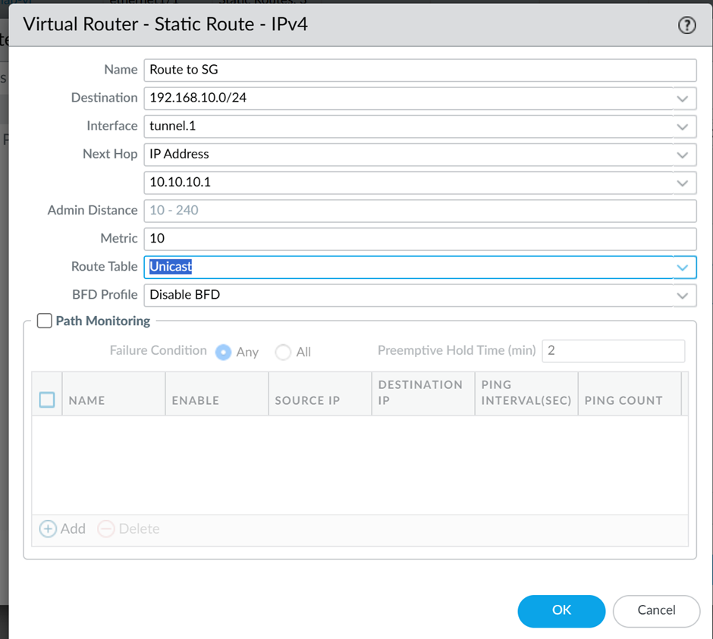

(destination is sg subnet that idk, next hop is sg tunnel ip which I also dk)

Static routes are configured in the virtual router to forward traffic between the sales, wan and vpn zones. Routes to SG subnets are also added with the next hop set to the SG tunnel IP. This way, the connectivity between departments no matter the location is smoother.

1. Security policies

Allow essential business traffic and restrict risky applications.

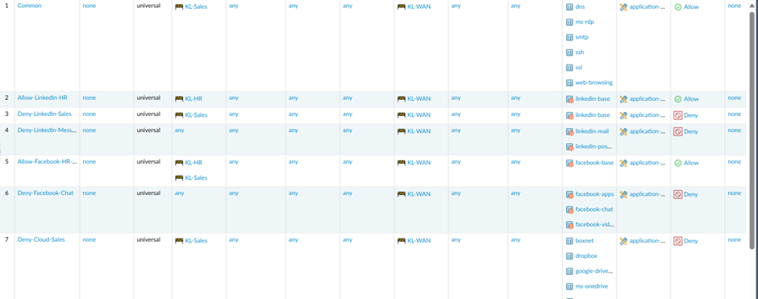

Policies are made to allow HTTP, HTTPS, DNS, Email(SMTP, IMAP, POP3), SSH and RDP traffic across the zones.

Rules added:

Allow LinkedIn for HR but block LinkedIn Messaging

Deny LinkedIn for Sales and IT

Allow Facebook for HR and Sales but block Facebook Chat

Deny Facebook entirely for IT

Deny all cloud storage applications (e.g., Google Drive, OneDrive) for HR and Sales

These policies ensure application visibility, control and data protection for the users as they visit different sites.

1. Decryption policy

Inspect encrypted traffic while excluding sensitive categories

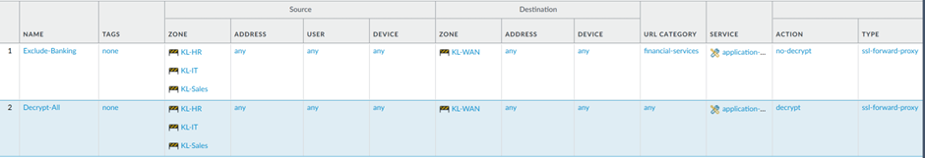

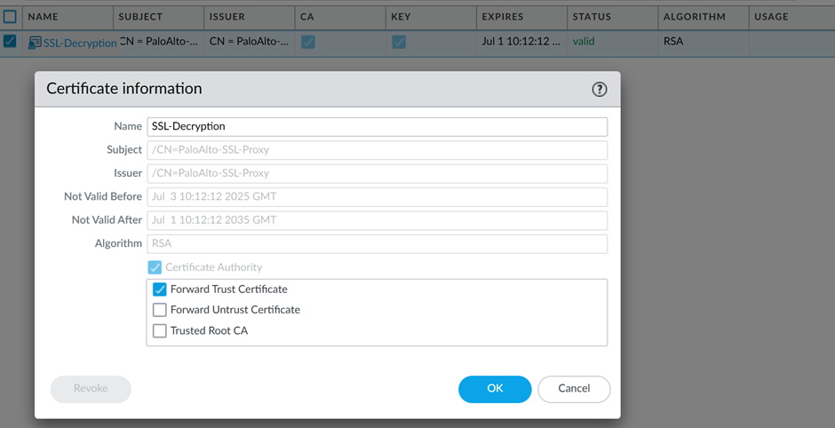

Also generate this certificate and add it into the device in the Sales department.

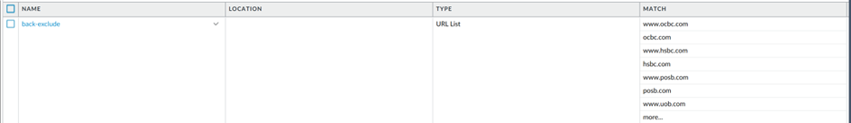

Added in a URL category with Banking Websites(ocbc.com, hcbc.com etc), so that it can be added to Exclude-Banking decryption policy so traffic from bank sites will be encrypted.

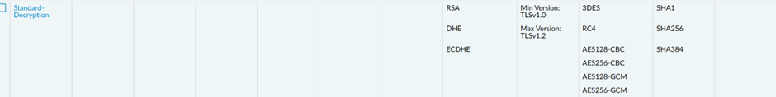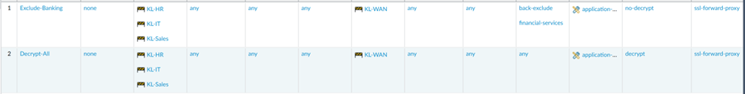

SSL forward proxy decryption is enabled for general traffic to detect hidden threats within encrypted sessions. A decryption exclusion rule was configured and added to bypass decryption for banking websites, maintaining compliance with privacy and financial data protection standards. Banking traffic may contain sensitive personal data like account numbers so the traffic needs to be encrypted.

1. VPN Configuration

Secure inter-office communication

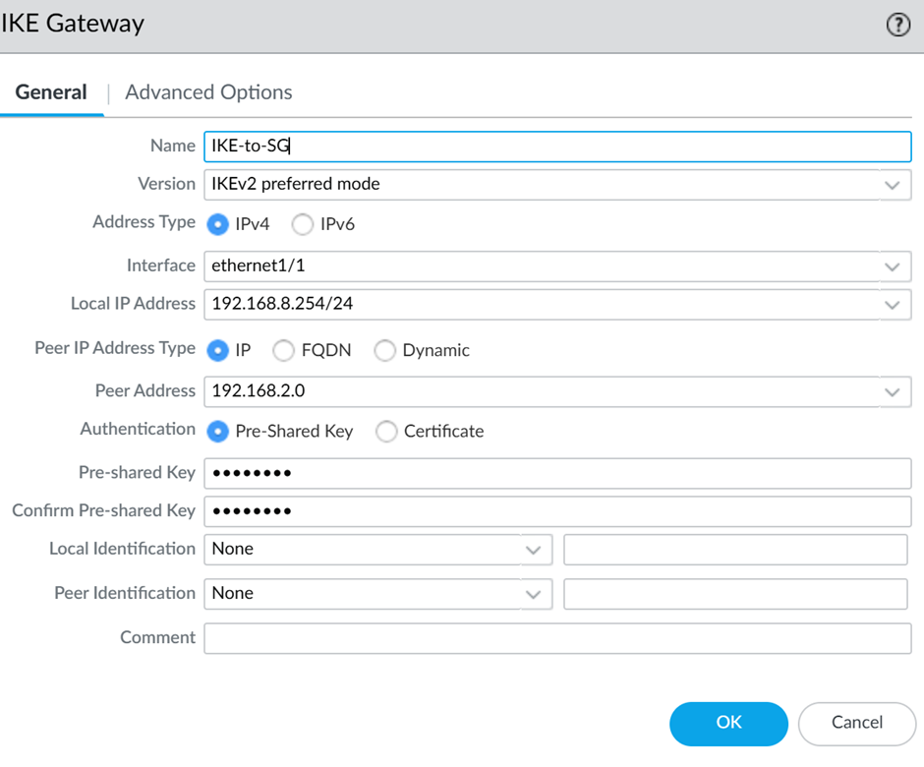

(peer ip should be the sg ip which idk so I anyhow put)



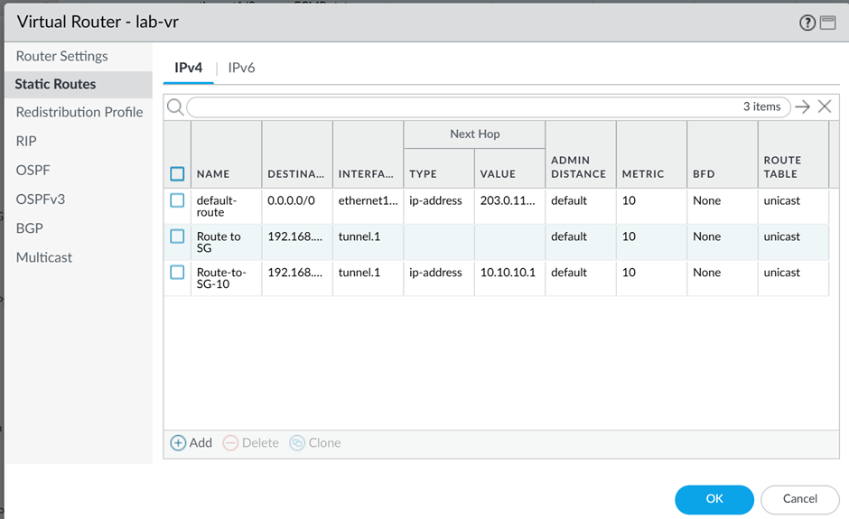

(add more for each subnet which idk yet, destination is the subnet ip, next hop ip would be the sg tunnel ip)

To establish secure site-to-site vpn between KL and SG offices IKE Gateway, IPsec tunnel and Routing were configured.

IKR Gateway authenticates the remote firewall and negotiate encryption parameters. Pre-shared key was configured on both sides to ensure mutual trust. The WAN interface initiates and accepts the VPN connections.

IPsec tunnel was configured between KL-FW and SG-FW using pre-shared keys and defined peers. This ensures secure key exchange and tunnel negotiation, forming the foundation of the IPsec tunnel.

Static routes and security policies were updated to allow traffic between KL and SG subnets which enables secure file and resource access across sites.

These configurations ensure communication between offices are encrypted and therefore secure data sharing.

1. Security profiles

Threat prevention and content filtering

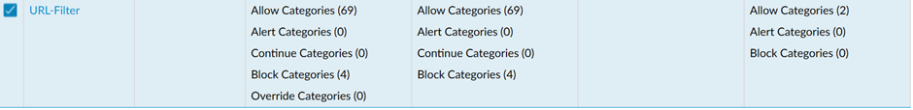

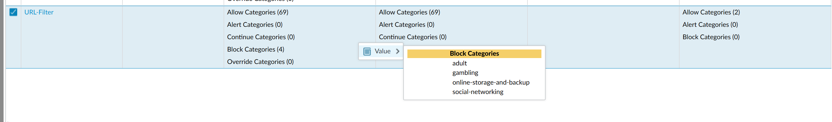

(Blocked adult sites)



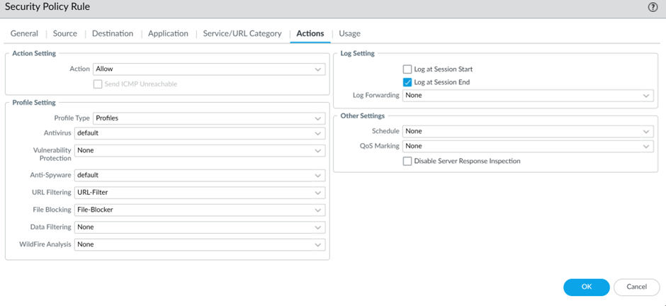

(do this for all allow type rules)

The security profiles Anti-virus, Anti-spyware, Vulnerability Protection, URL Filtering and File Blocking were applied to all “allow” type rules so that even if traffic is allowed it will be inspected for malware, exploits, and policy violations.

1. NAT

Enable internet access and avoid IP conflicts



Source NAT rules were configured to allow outbound internet access from internal zones using the firewall’s public interface IP. This helps mask internal IPs and ensures proper routing between KL and SG offices without subnet overlap issues.

1. Service groups

Simplify and manage allowed ports/services

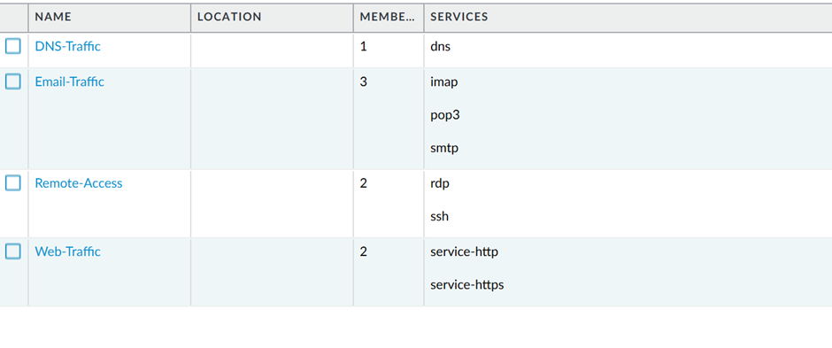

Custom service groups were added for common business traffic like Web Services, Email Services and Remote Access Services. This simplifies security rules as services are groups logically rather than adding each port individually.

SSH – allows for secure logging in to Linux-based systems.

RDP – allows for remote control of Windows machines like they’re sitting in front of them.

1. Application Filter



This filter blocks the categories for all messaging and storage apps and allows the rule to adapt over time even if there are app variants without need to manually track new App-IDs.

## **3.3. VPN Setup**

1. Ensure that both firewall IP address is different

KL Firewall: 192.168.1.254

SG Firewall: 10.10.1.254

Step 1: Enter configuration mode

Command: configure

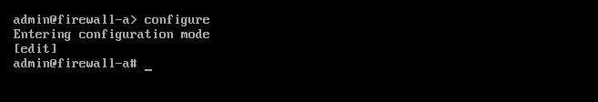

Step 2: Set an IP address for one of the firewalls [SG firewall in this case]

Command: set deviceconfig system ip-address 10.10.1.1 netmask 255.255.255.0 default-gateway [IP address]

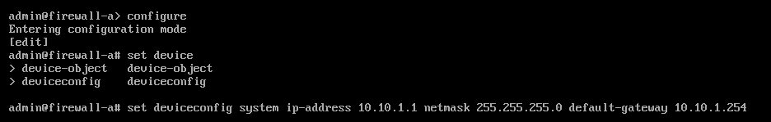

Step 3: Commit the changes

Command: commit

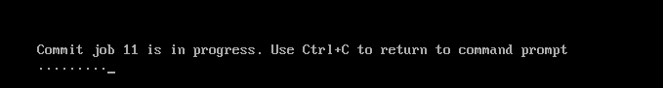

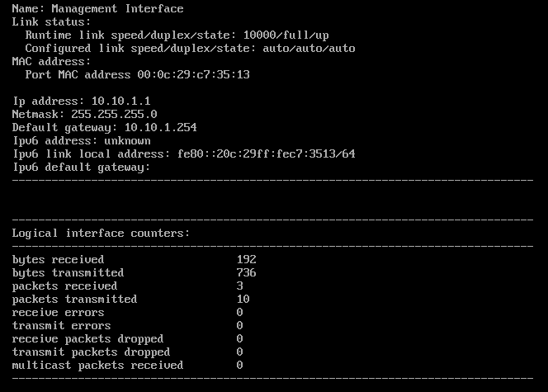

Successfully changed the firewall IP address:

2. Create an Internet Key Exchange Profile

***Steps***: *Network > Network Profiles > IKE Crypto*

***Purpose***: It defines how the two VPN peers will **safely exchange** their key during the first phase of the IKE negotiation, such as: **encryption, authentication, and key lifespan algorithms**. Without matching the settings on both firewalls, the VPN tunnel will **not** be able to **establish**.

3. Create an IPSec Crypto Profile

***Steps***: *Network > Network Profiles > IPSec Crypto*

***Purpose***: It helps to specify the encryption and authentication methods for the data in Phase 2 of the VPN tunnel. With the use of the **algorithm**, it ensures that the **traffic that passes through the VPN is private and secure**

4. Create IKE Gateway

Steps: *Network > IKE Gateways > Add*

Purpose: It creates a VPN connection using the public IP address of both firewalls. This allows us to specify the **remote peer**, **pre-shared key** and **link the IKE crypto profile where we have created previously**. By doing this, it allows both parties to **identify** and **authenticate** each other.

5. Create Tunnel Interface

Steps: *Network > Interfaces > Tunnel > Add*

Purpose: The tunnel **serves as the gateway** to the separated site.

6. Create IPSec Tunnel

Steps: *Network > IPSec Tunnels > Add*

Purpose: This is an **important** setup that helps to creates the secure tunnel. It helps to bind the **IKE Gateway** and **Tunnel interface** to the **IPSec Crypto Profile**.

**\*Without this step, there will not be encryption\***

7. Create Security Policies

Steps: *Policies > Security > Add*

Purpose: This step is to control what traffic is **allowed into and out** of the **VPN *[Different from the one set up in KL and SG firewall respectively]***. This helps to **restrict illegal access** and enable legitimate access between the sites.

8. Add Static Routes

Steps: *Network > Virtual Routers > Static Routes*

Purpose: In this step, it tells the firewall to **route traffic intended** for the **remote subnet through the tunnel**. Without this, the firewall will not know how to reach the remote network.

9. Commit Configuration

Steps: *Click “Commit”*

Purpose: It will **apply the changes** above to the firewall. **No changes will be taken** until we click “Commit”

How to check if VPN is being set up?

# **Testing & Results**

## **SG Testing:**

### **General Network Traffic:**

Test: Web Traffic (HTTP/HTTPS)

Expected Results: Successful access to HTTP and HTTPS websites.

Result:

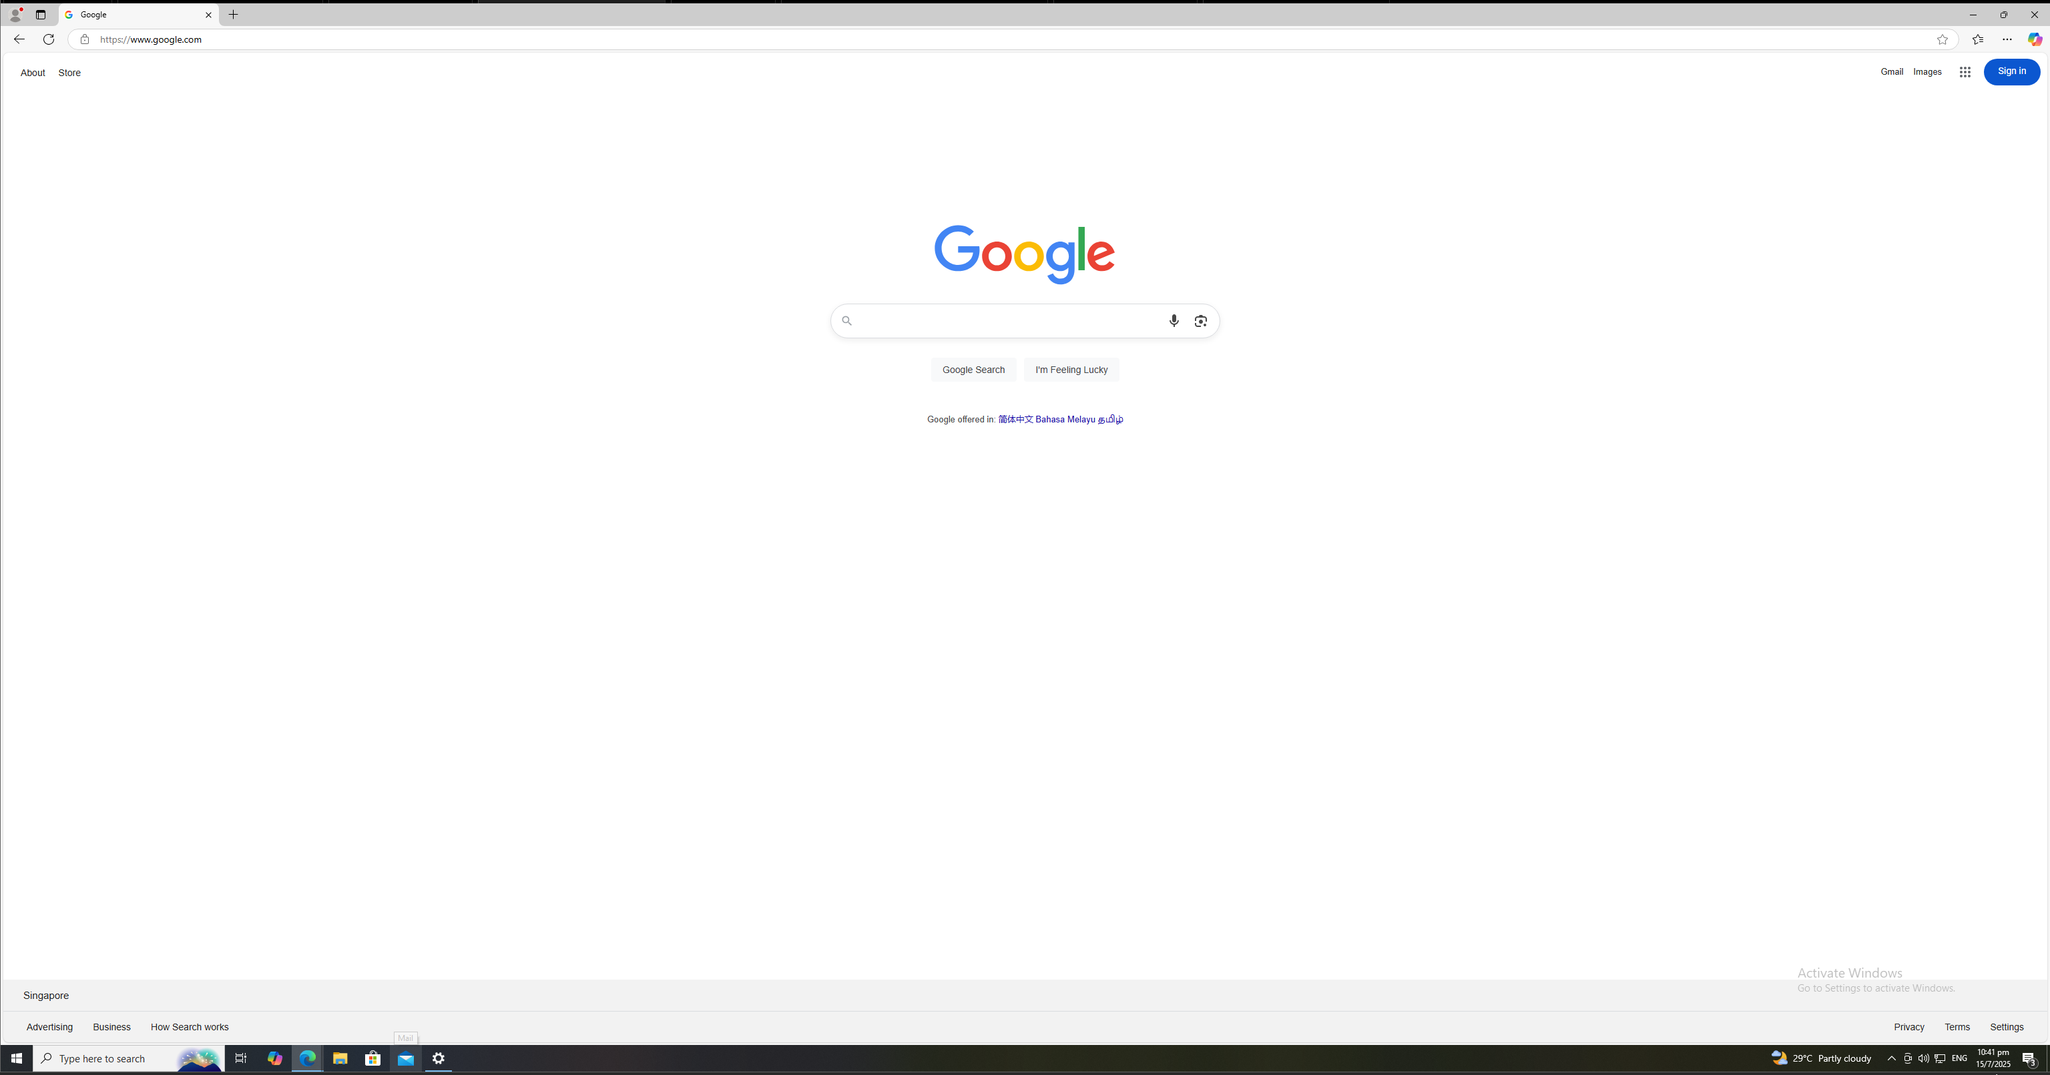

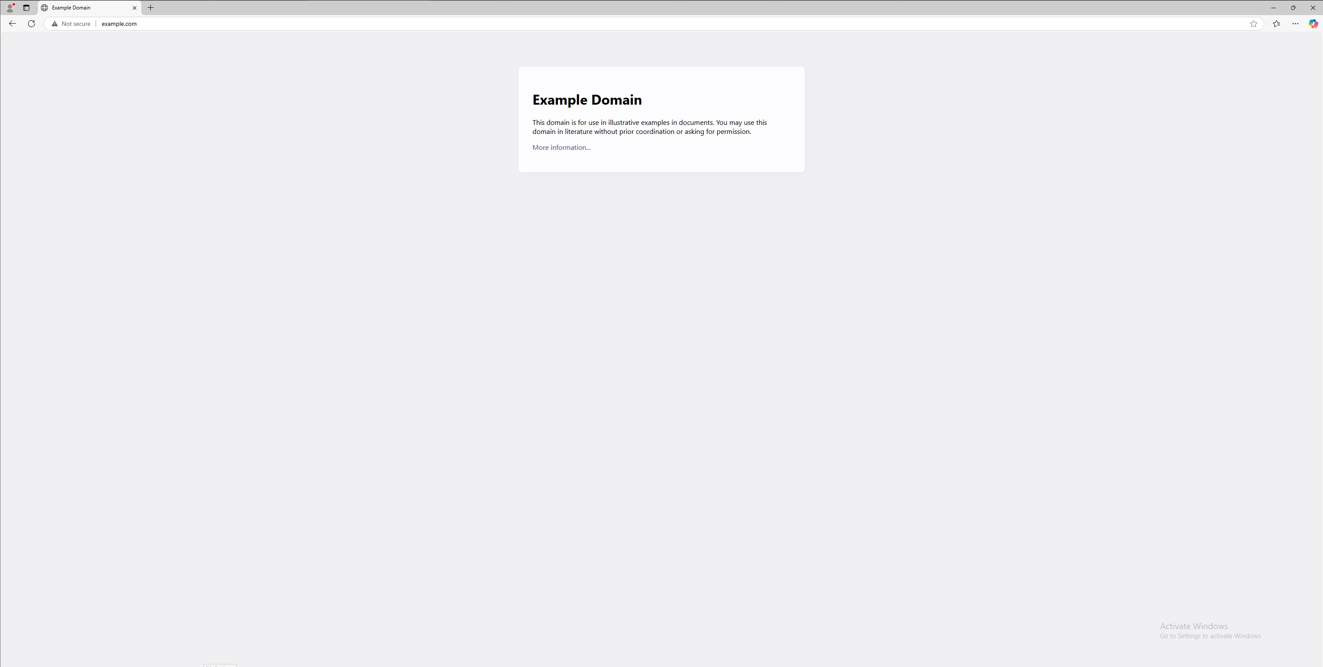

Test: DNS Traffic

Expected Result: Firewall should allow DNS packets.

Result:



Test: Email Traffic

Expected Result: Emails are successfully sent and received

Result:

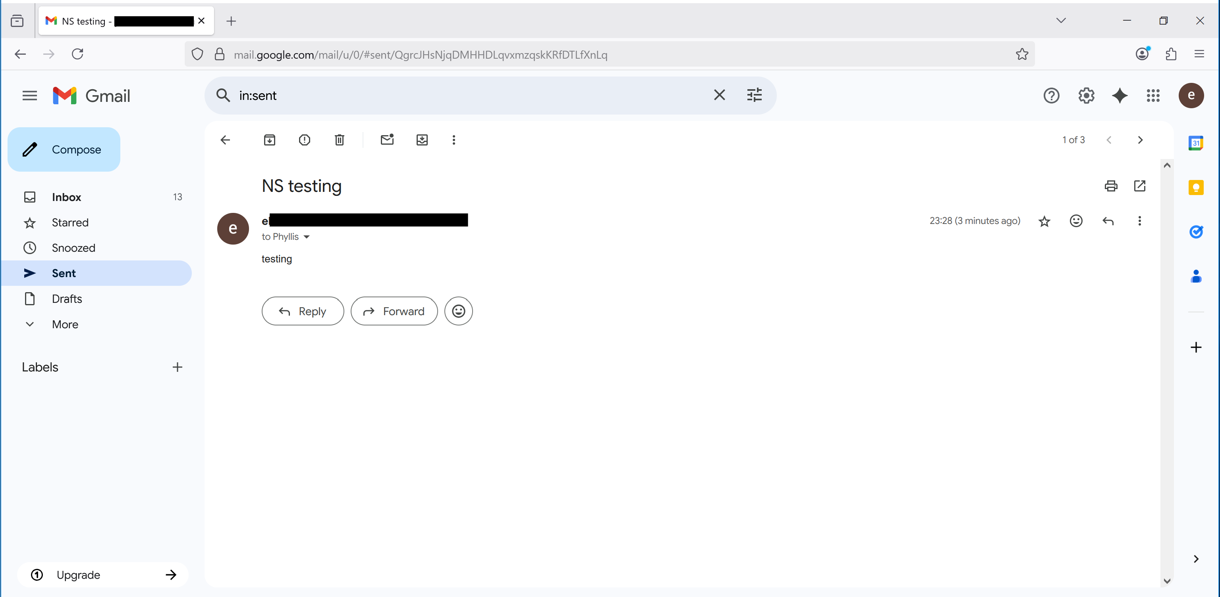

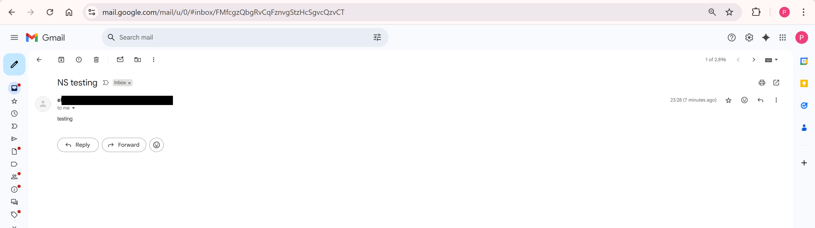

Test: Remote Access (SSH/RDP)

Expected Result: Successful SSH/RDP connections

SSH:

Setup on Ubuntu:

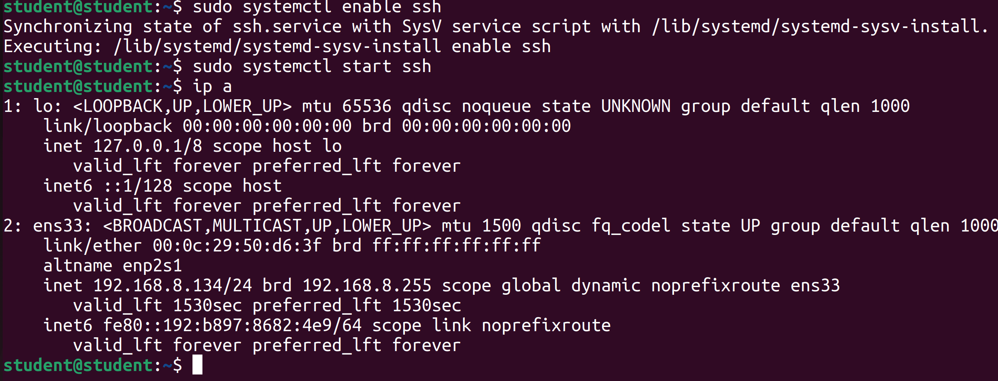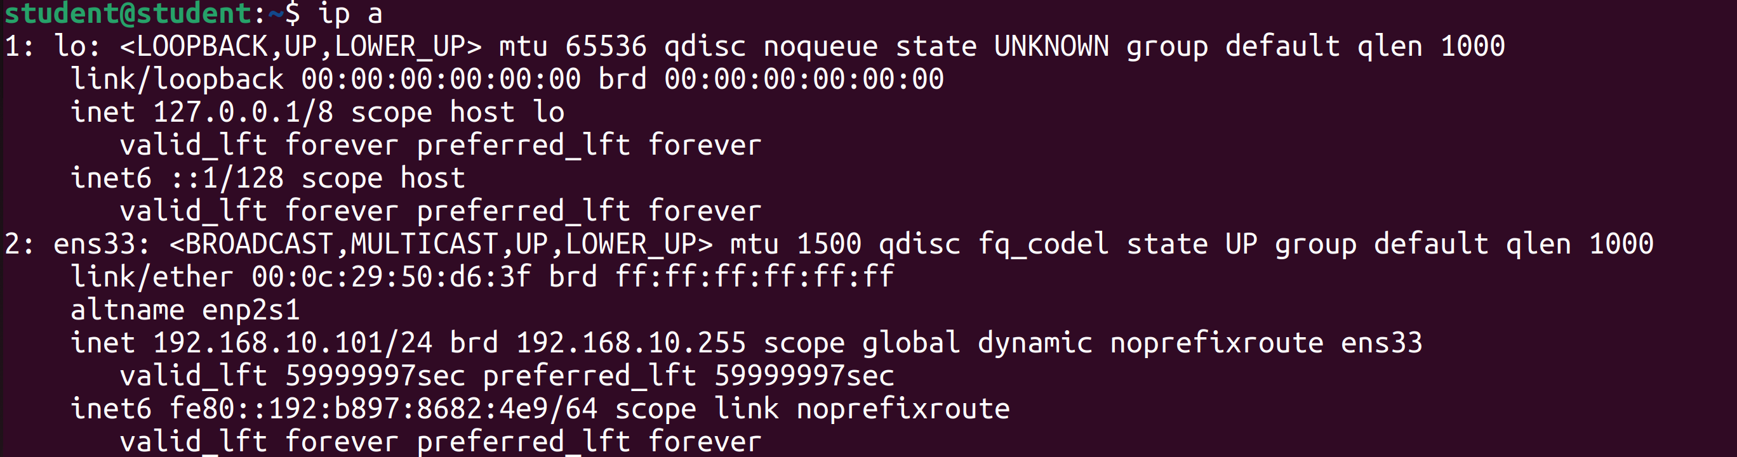

Result: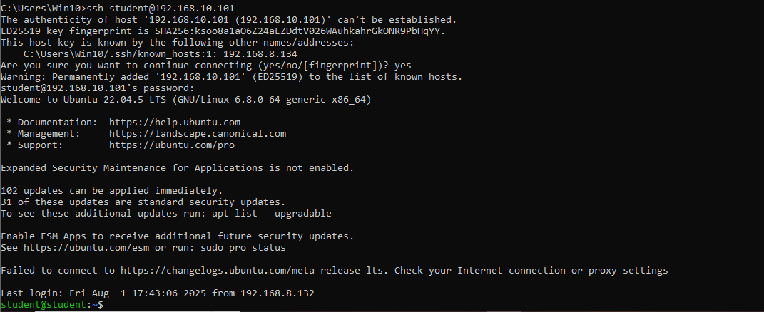

RDP:

Install xfreerdp on Ubuntu

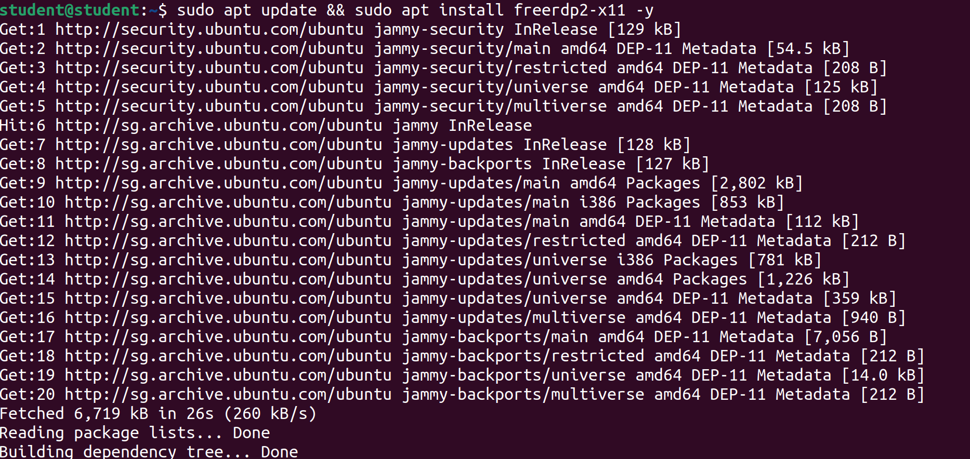

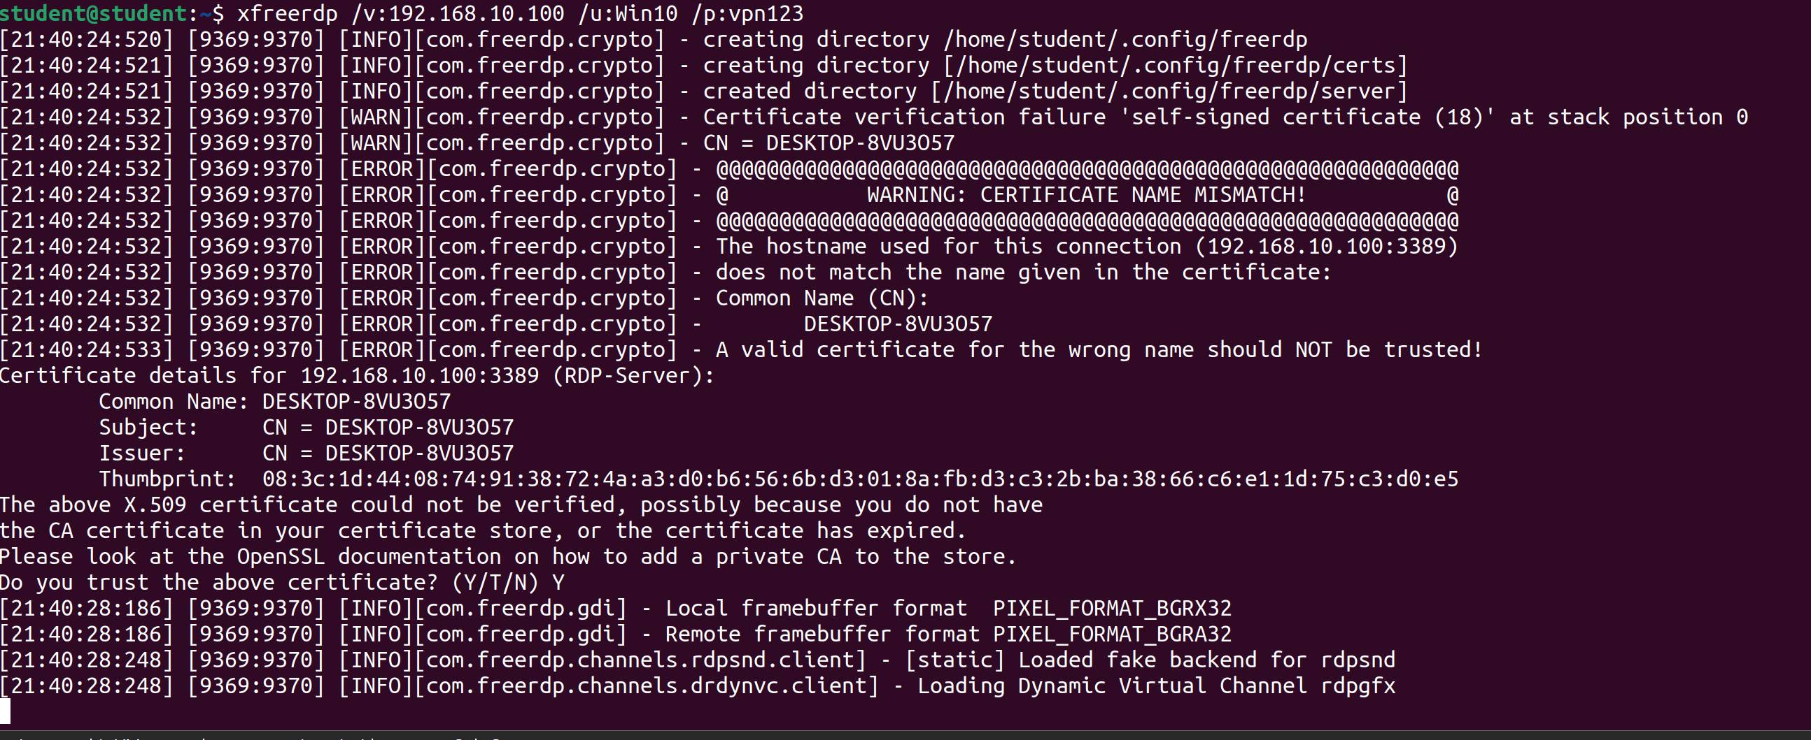

Result:

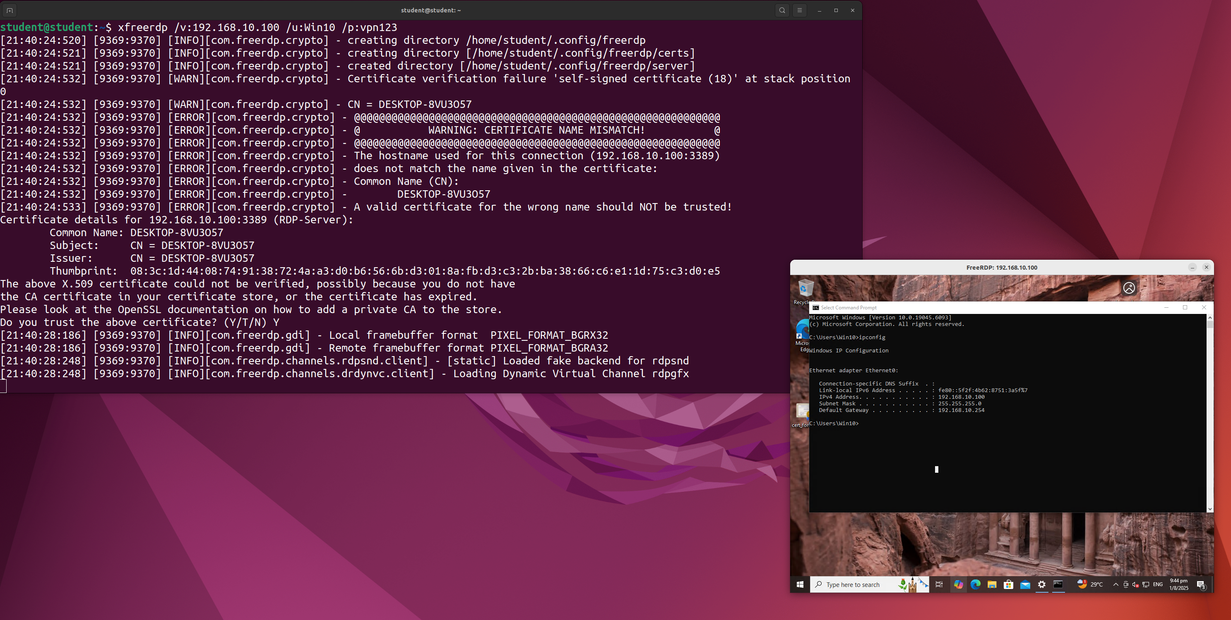

### **Decryption Policy:**

1. Non-banking website decryption:

* When non-banking website traffic is decrypted, the firewall acts as an SSL forward proxy. It intercepts the encrypted connection, generates a new certificate for the websites, and re-signs it using its own Forward Trust CA. The browser receives and trusts the firewall-issued certificate, hence, seeing that certificate confirms the traffic was successfully decrypted and inspected.
* 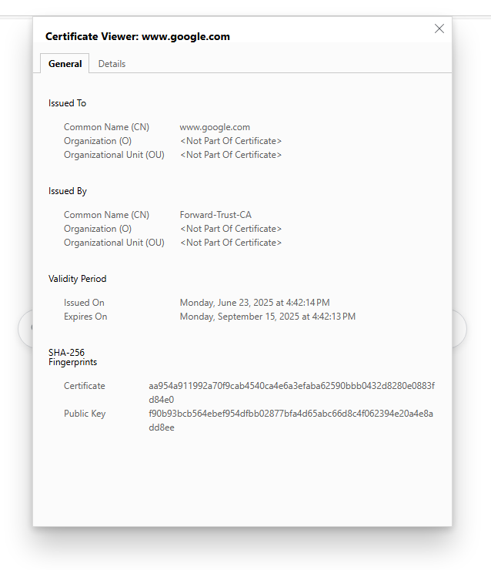

1. Banking website no decryption:

* When SSL decryption occurs, the firewall re-signs the website’s certificate using its Forward Trust CA. The below screenshot shows the browser’s original certificate issued by the bank’s trusted public Certificate Authority. Therefore, seeing the original certificate, confirms that no decryption took place for the banking site.
* 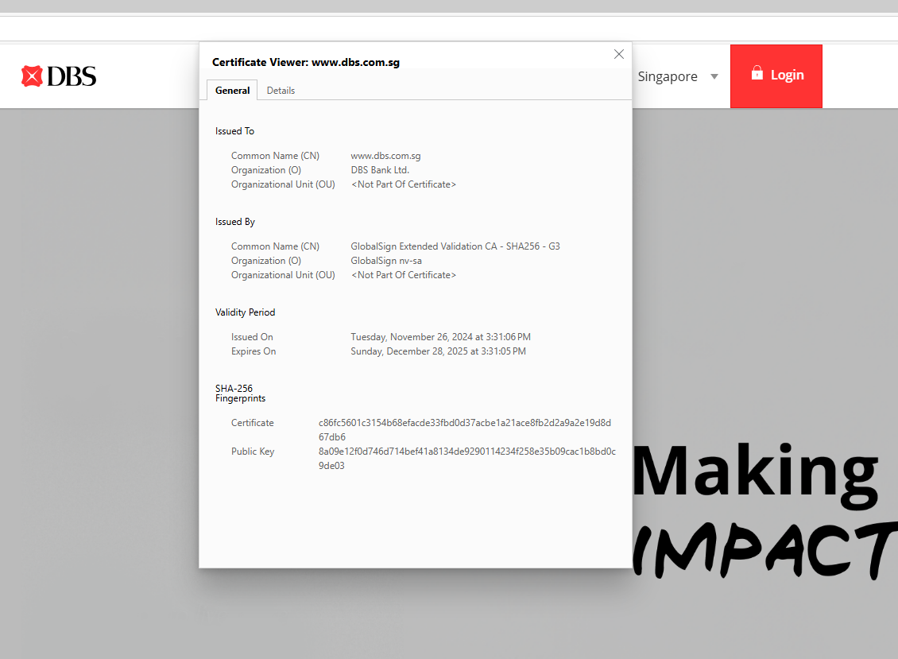

### **HR department:**

Test: Access LinkedIn.

Expected Result: Successful access to LinkedIn.

Result:

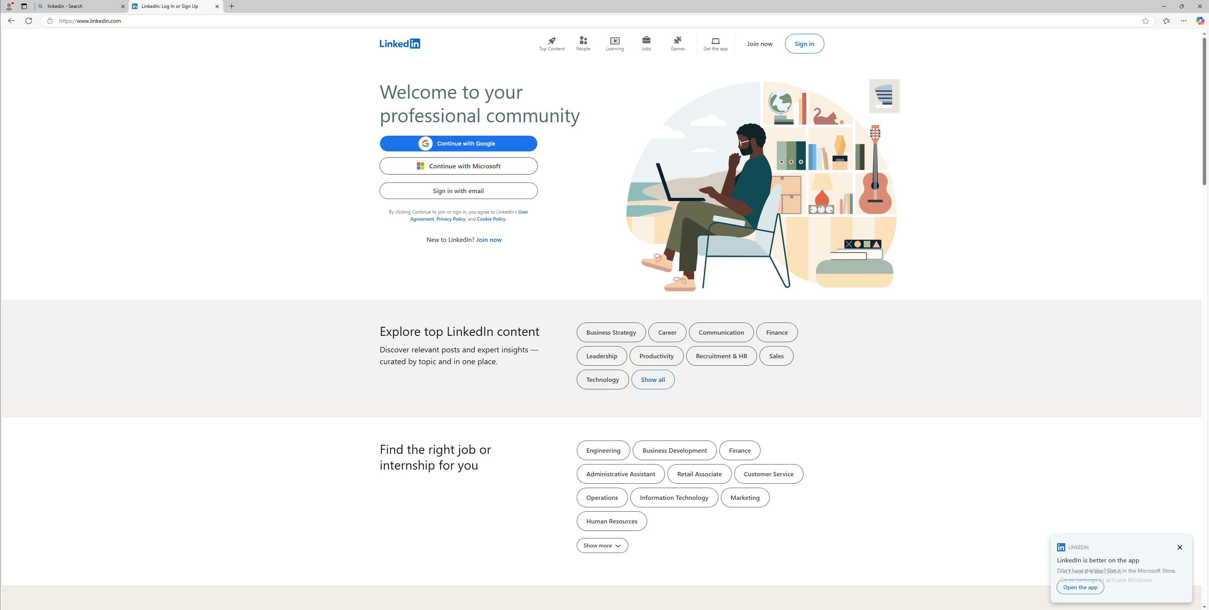

Test: Attempt to use LinkedIn Messaging.

Expected Result: LinkedIn Messaging is blocked.

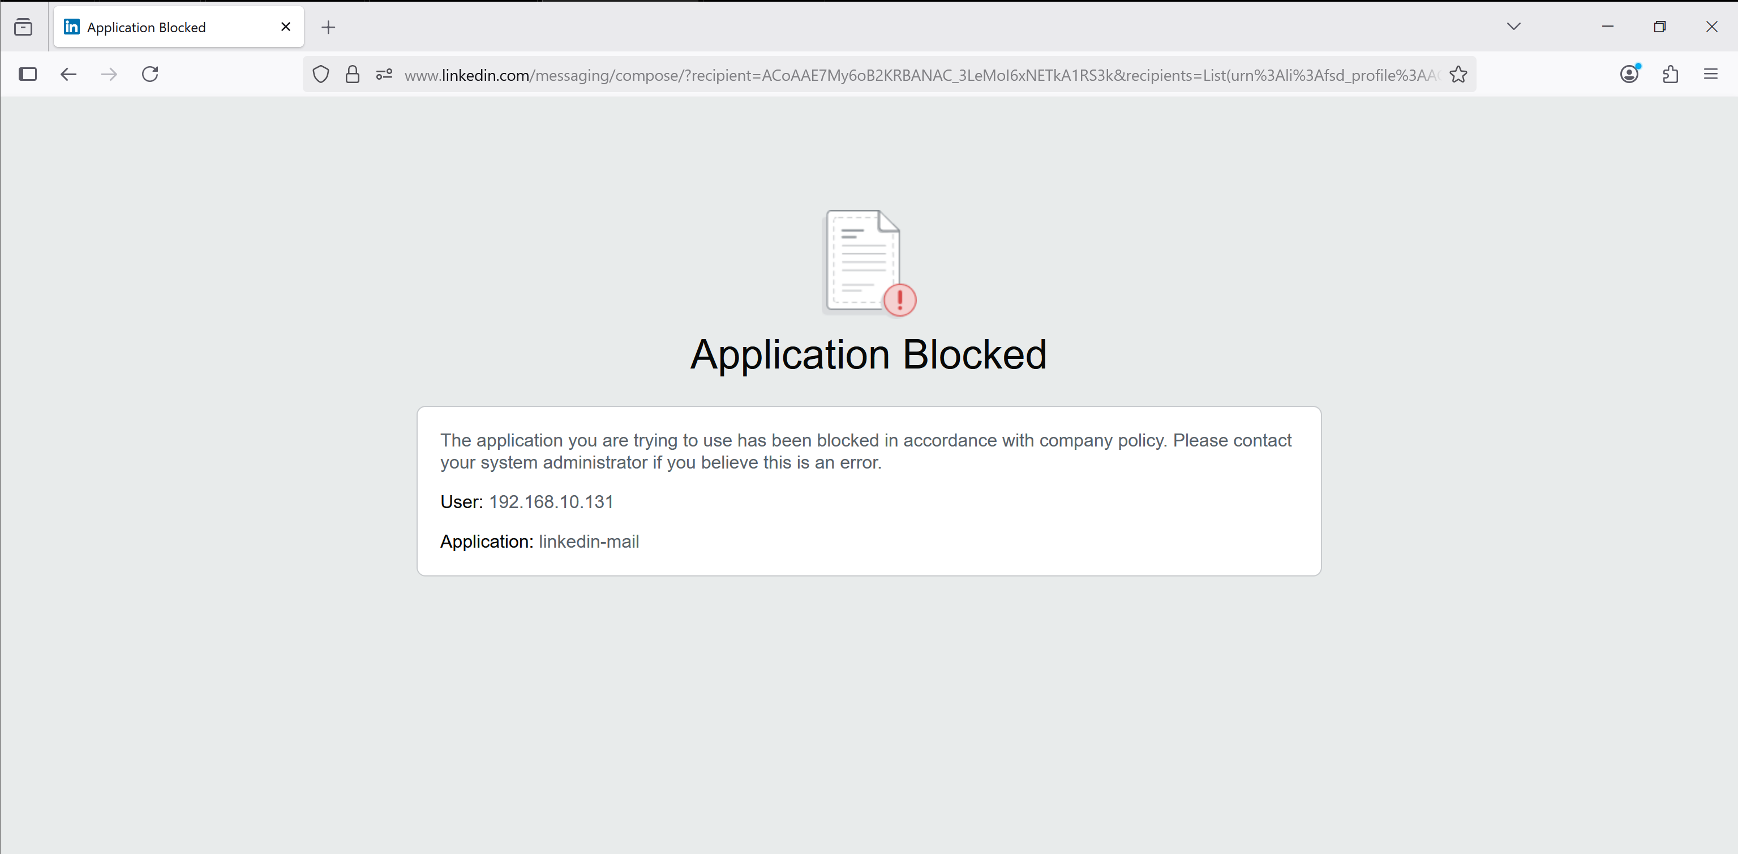

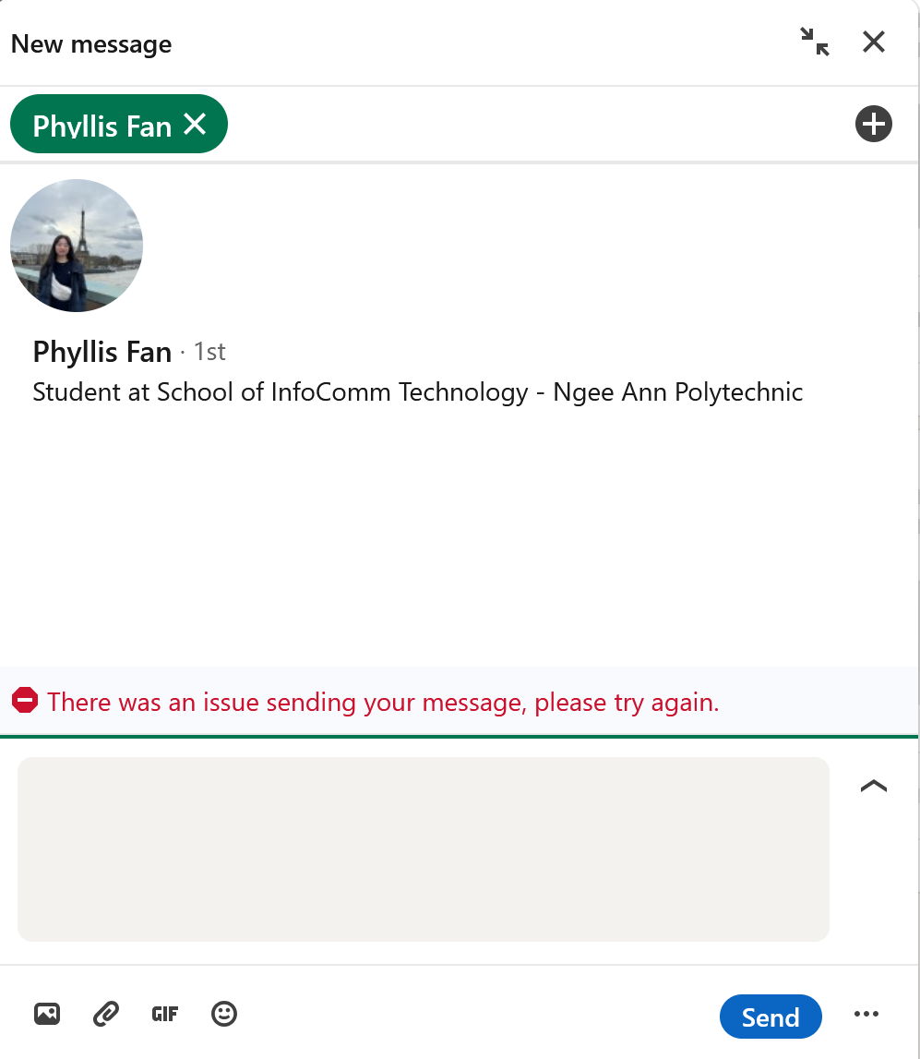

Test: Access Facebook.

Expected Result: Successful access to Facebook.

Result:

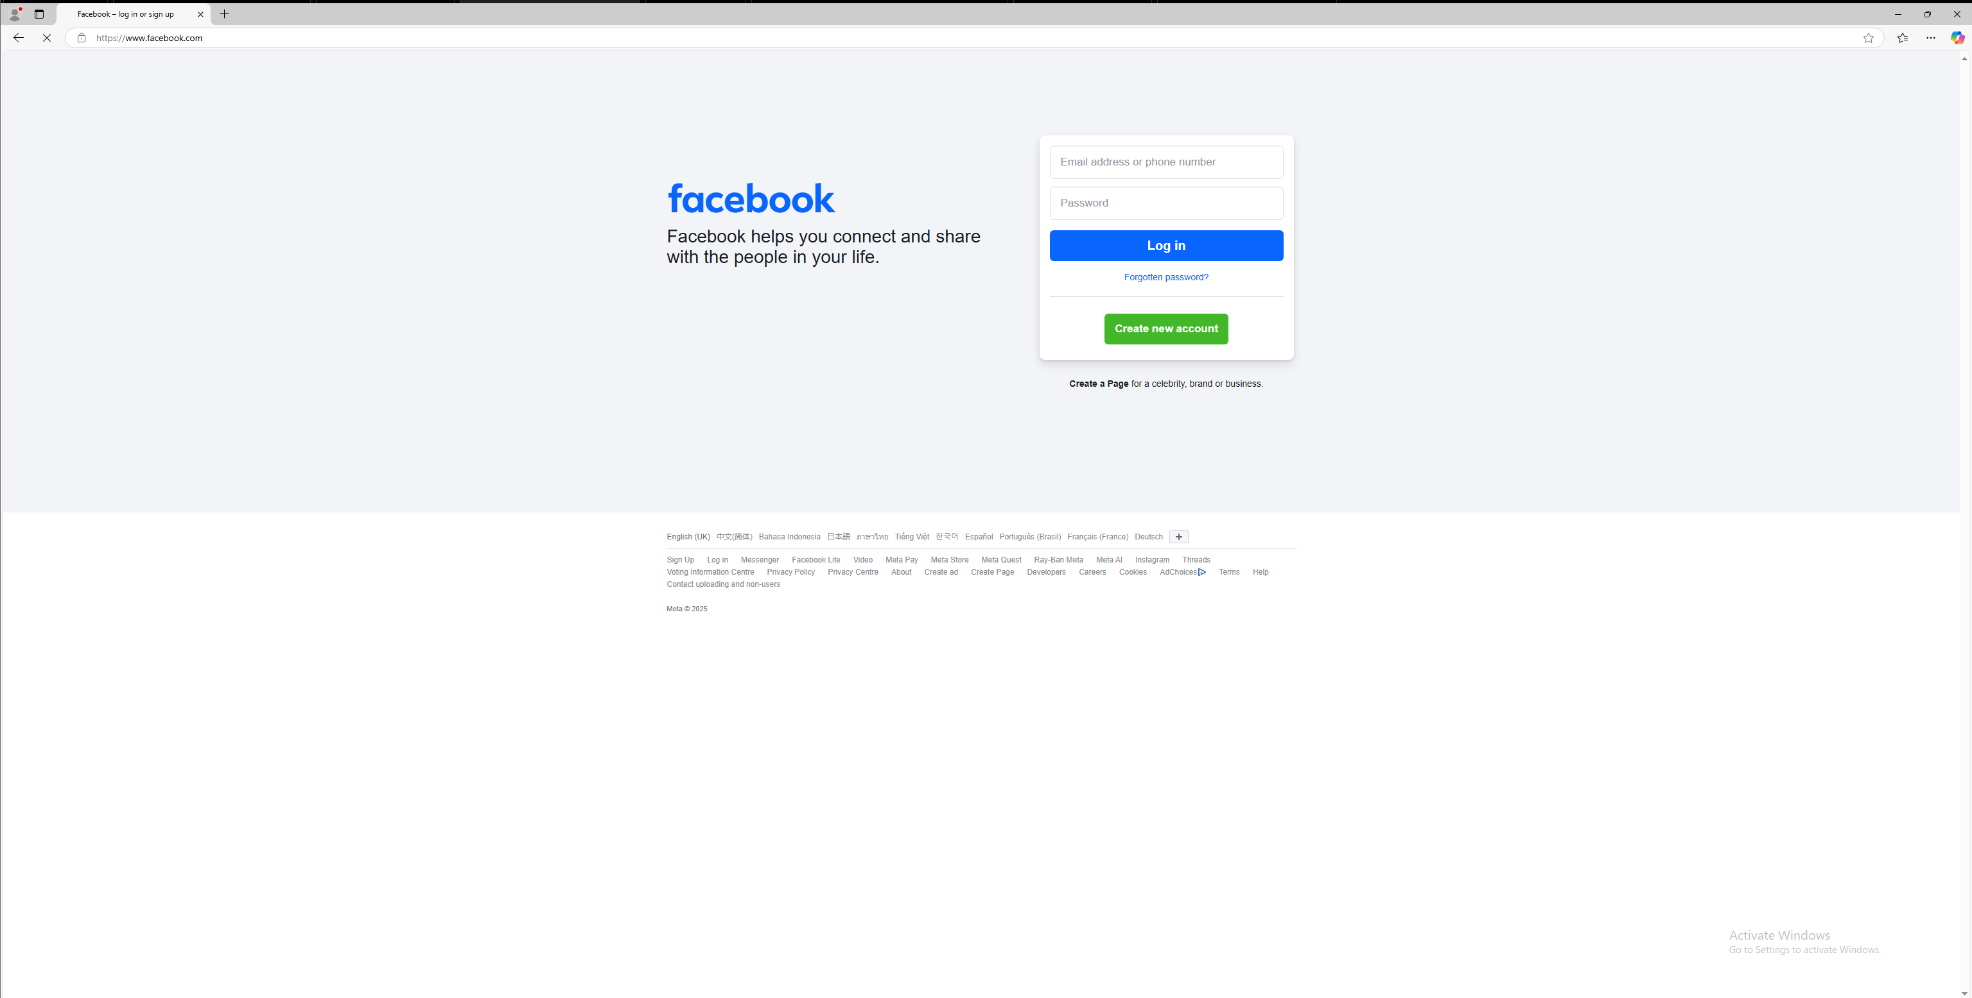

Test: Attempt to use Facebook chat.

Expected Result: Facebook chat is blocked.

Result:

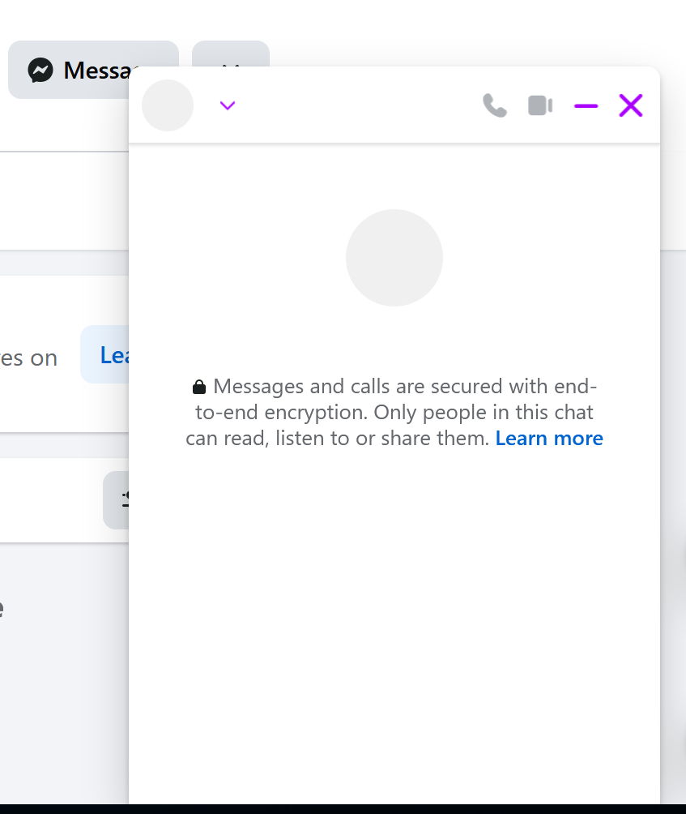

Test: Attempt to access Google Drive (one of the online storage services).

Expected Result: Access to these services is denied.

Result:

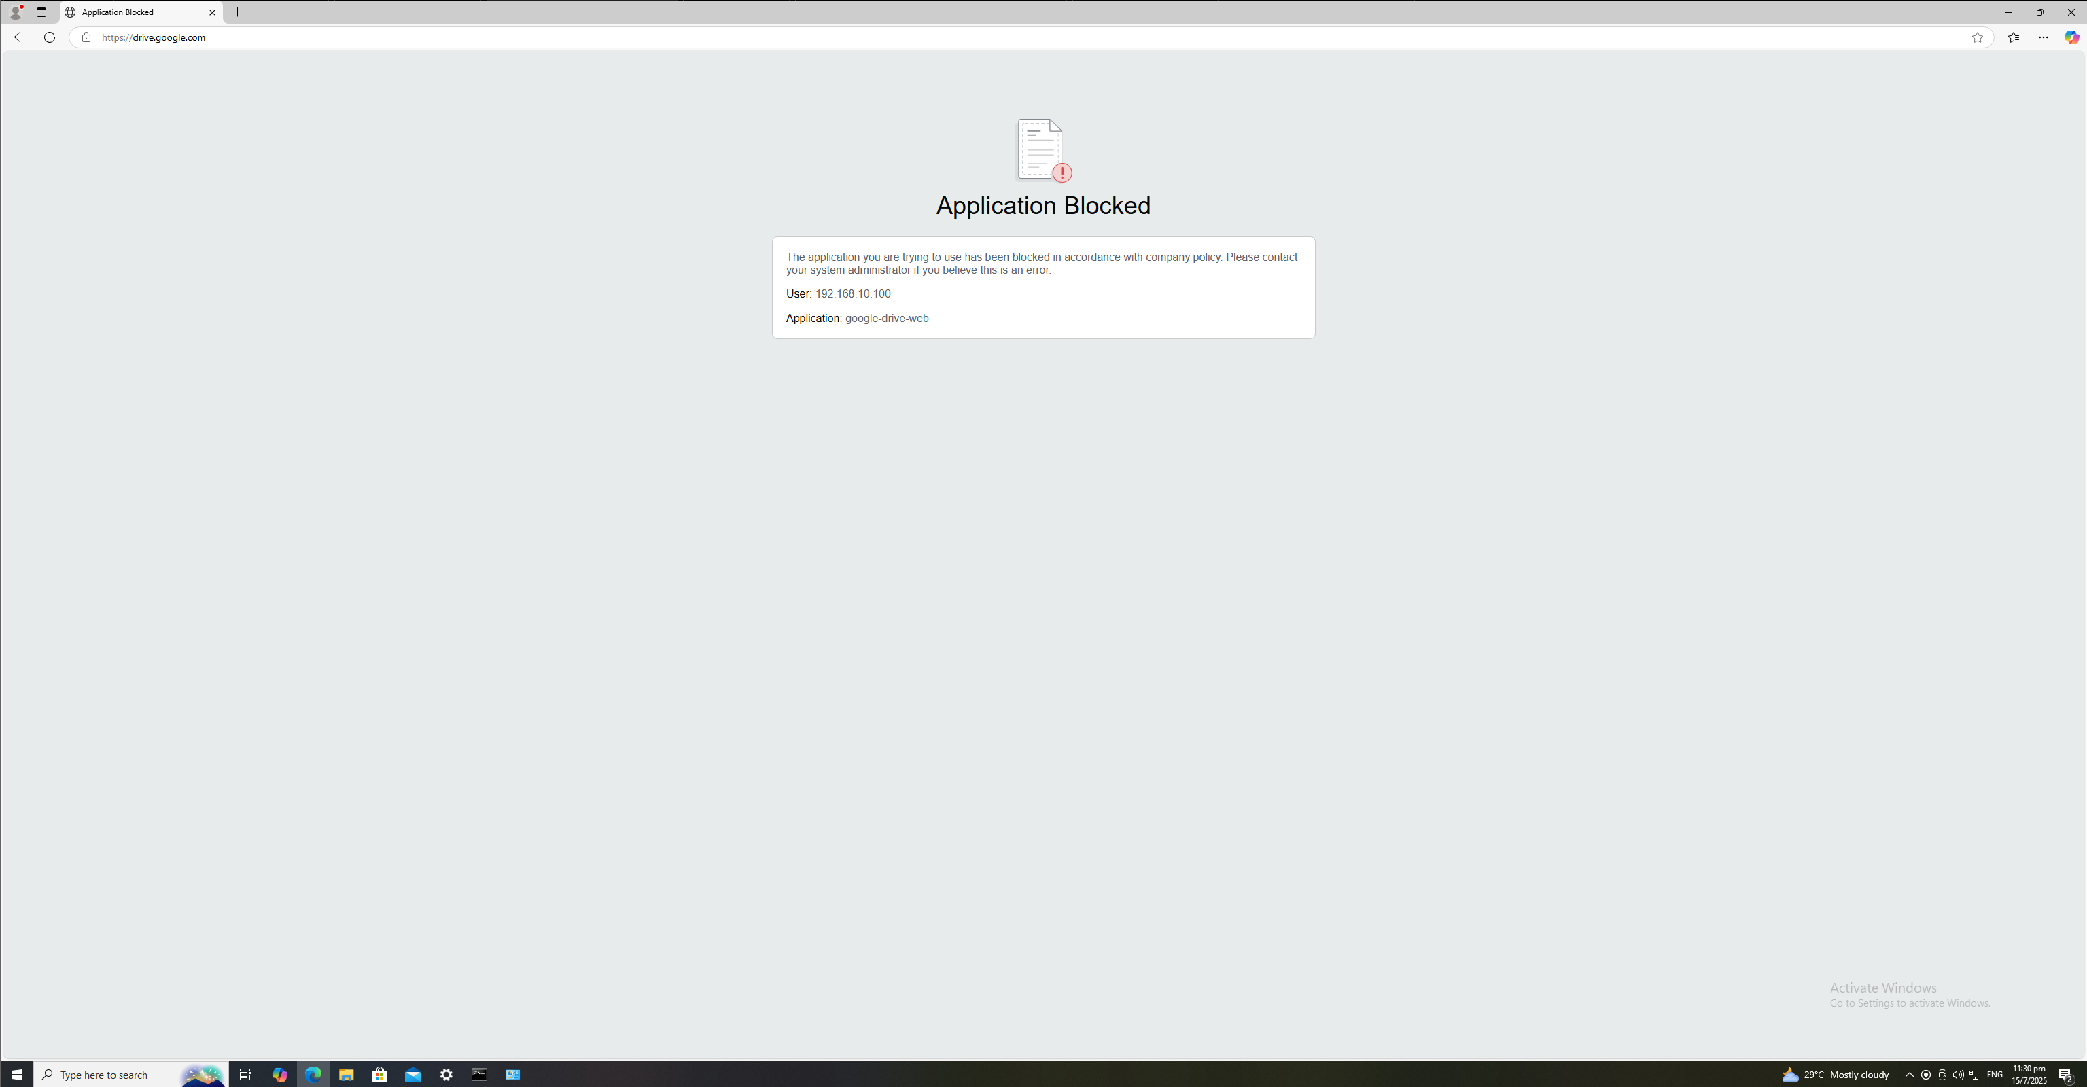

### **IT department:**

Test: Access LinkedIn.

Expected Result: Access to LinkedIn is denied.

Result:

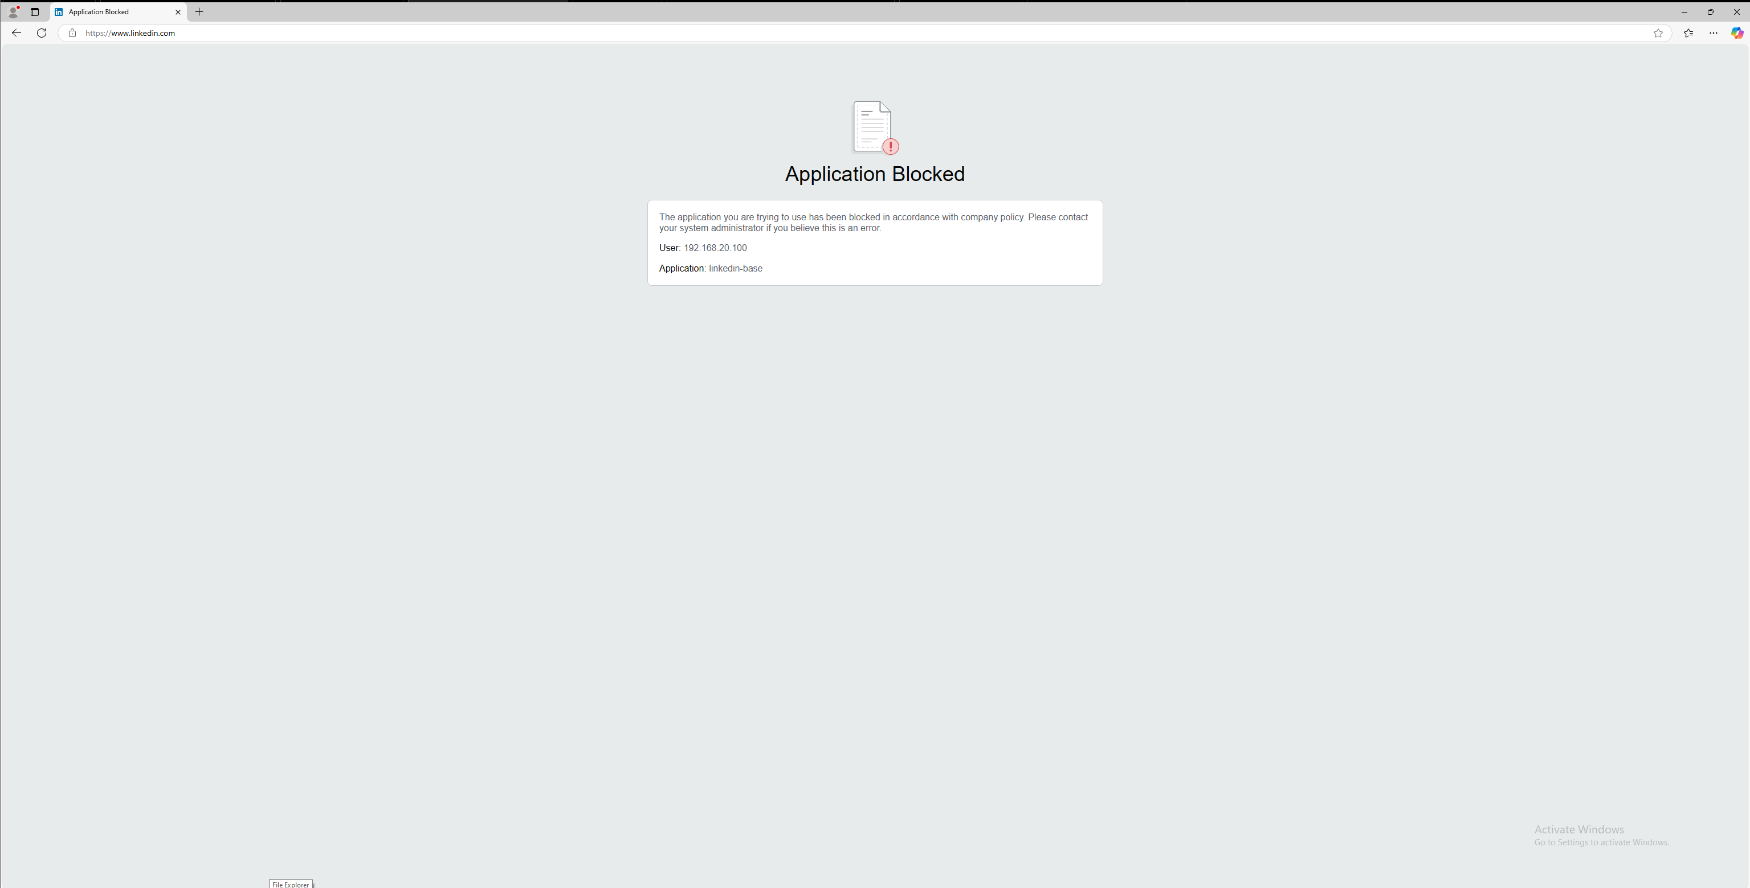

Test: Attempt to access Facebook.

Expected Result: Access to Facebook is denied.

Result:

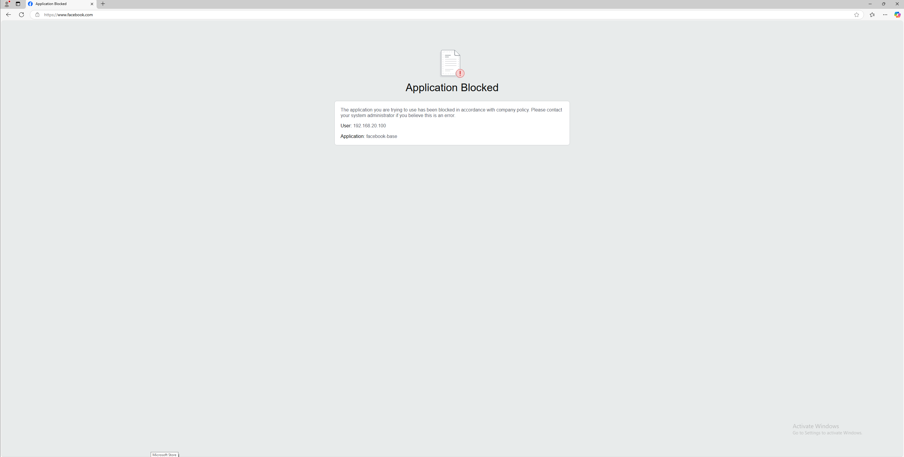

## **KL Test Results:**

* Internal Traffic Routing

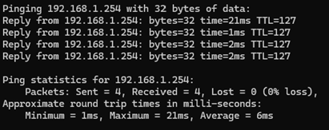

Device from Sales zone is able to ping another device in sales zone

* Working Decryption

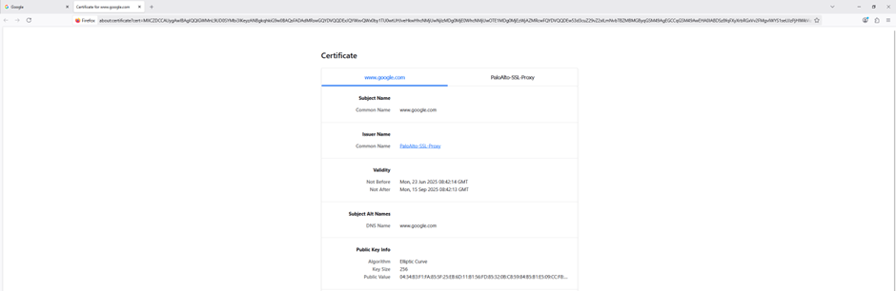

On all other websites other than banking ones, (in this case its google.com) the issuer for the certificate will be the firewall as the traffic is being decrypted which allows the firewall to see inside the encrypted tunnel so that it can scan for malware, enforce policies, control apps and prevent data leak.

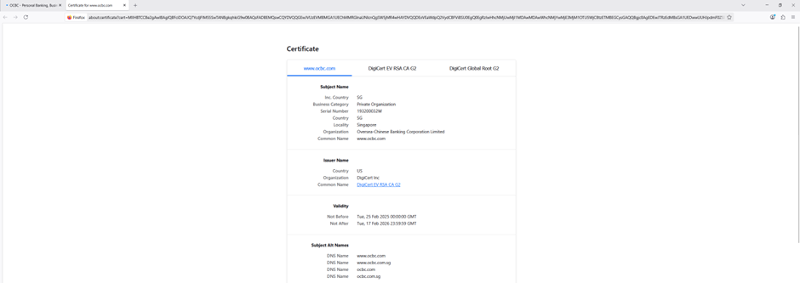

For banking websites the issuer of the certificate is from companies like DigiCert which means the traffic is not being decrypted and protects sensitive data that could be exposed

* Application Blocking Control

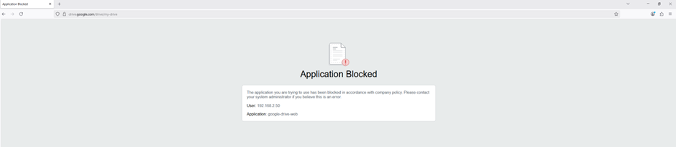 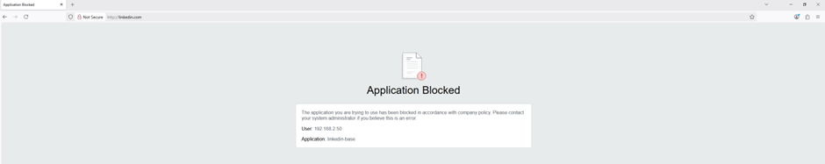

Applications like linkedin and google drive are blocked according to the company requirements.

* SSH testing

1. Run SSH on linux based system, in this case using ubuntu

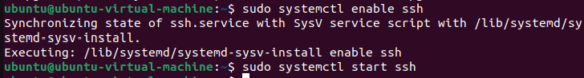

1. Use SSH client from windows

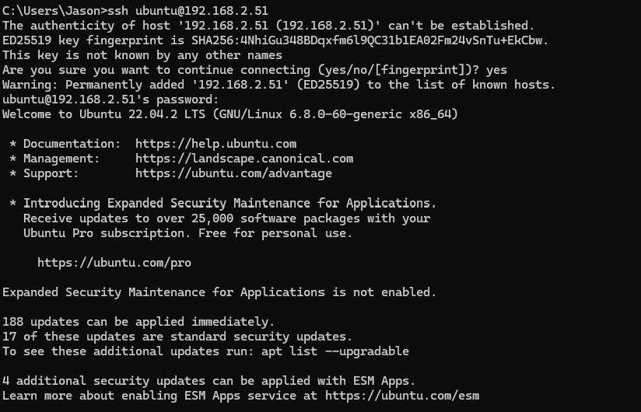

This shows SSH is working, and your firewall is allowing it.

* RDP testing

(using xfreerdp to connect from ubuntu to windows)

Command: xfreerdp /u:Jason /p:qwerty /v:192.168.2.50

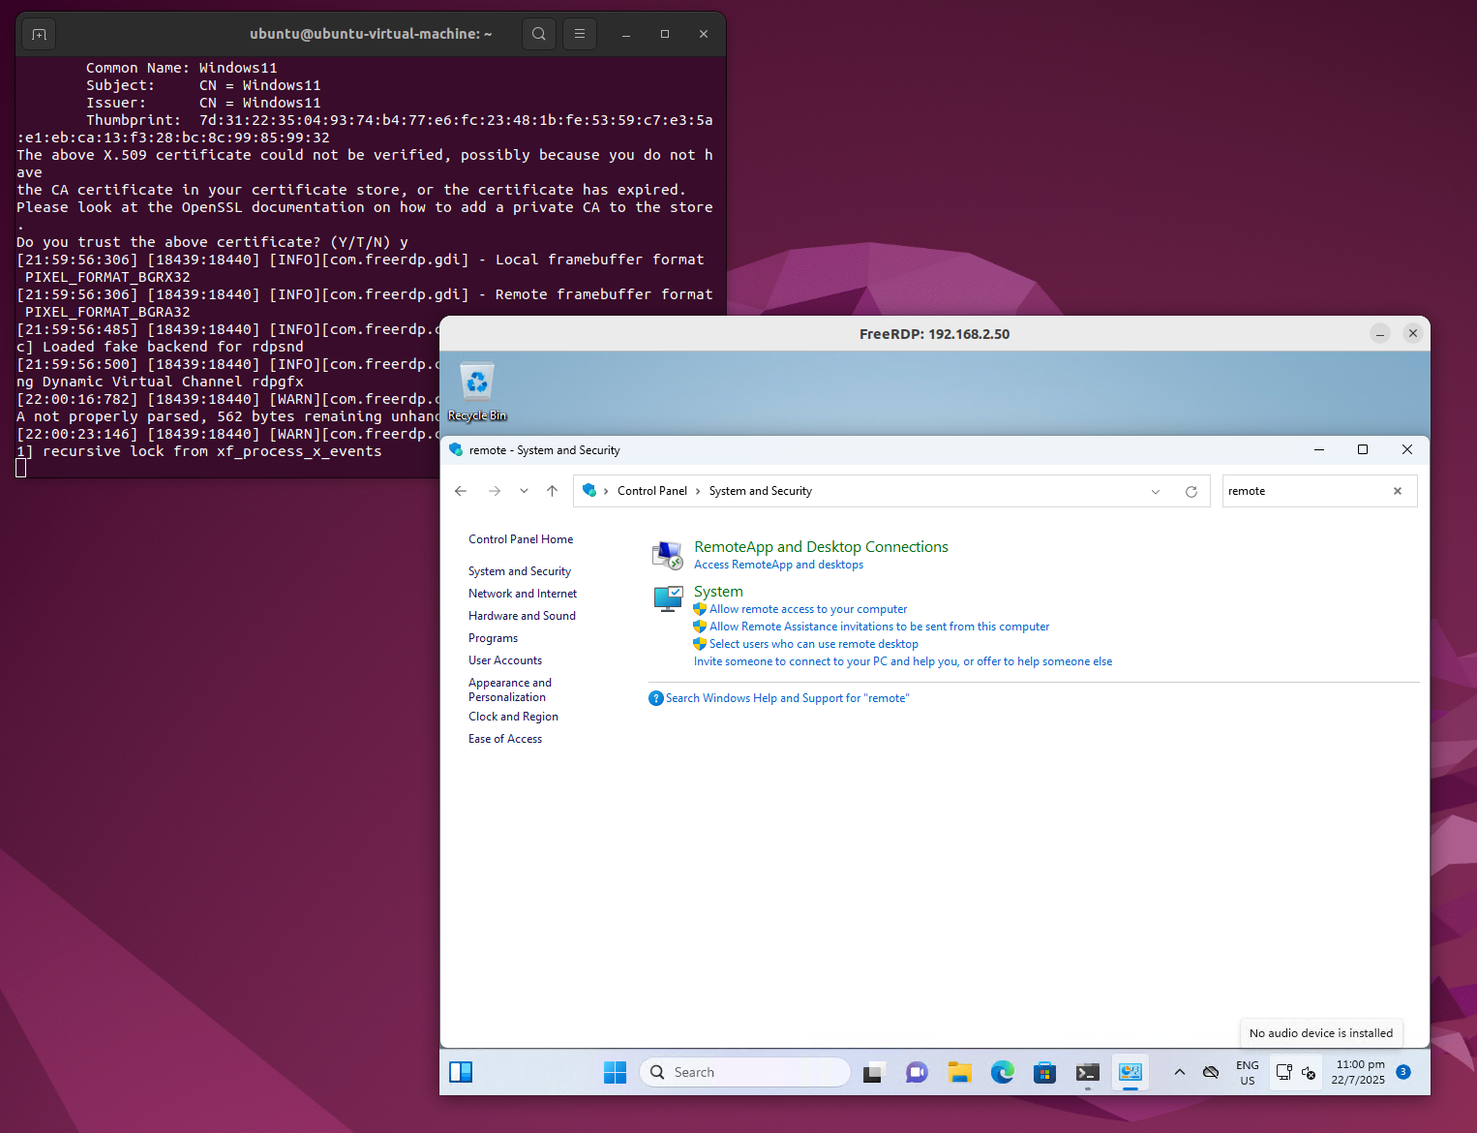

This shows that the **firewall** is allowing **RDP traffic** (TCP port 3389) from one VM to another.

# **Conclusions & Recommendations**

# **Appendix**

## **6.1. Member Contributions**

|  |  |  |  |
| --- | --- | --- | --- |
| **No.** | **Member Name** | **Contributions (Role & tasks assigned and accomplishments)** | **Remarks** |
| **1.** | Shavelin | Setup secure LAN-to-LAN connection (VPN) between SG office and KL office + explanation + testing |  |
| **2.** | Cloe | KL Office configuration + explanation + testing |  |
| **3.** | Phyllis | SG Office Configuration + explanation + testing |  |
| **4.** | Jaya | Business requirement Analysis and Detailed Firewall Comparisons + Conclusion & Recommendations |  |

## **6.2. Additional Screenshots / References**

- <https://www.gartner.com/reviews/market/network-firewalls>

- <https://www.fortinet.com/products/next-generation-firewall>

- <https://www.comparitech.com/net-admin/next-gen-firewalls/>

- <https://www.paloaltonetworks.com/resources/demos/application-visibility-and-control>

- <https://docs.paloaltonetworks.com/network-security/ipsec-vpn/administration/set-up-site-to-site-vpn/set-up-an-ike-gateway/export-a-certificate-for-a-peer-to-access-using-hash-and-url>

- <https://youtu.be/LeJVUjRCzKo?si=KXgPI_DcW4_0RL2C>